**Web Application Development Lab - R20**



22Q71A4454

**Web Application Development Lab - R20**

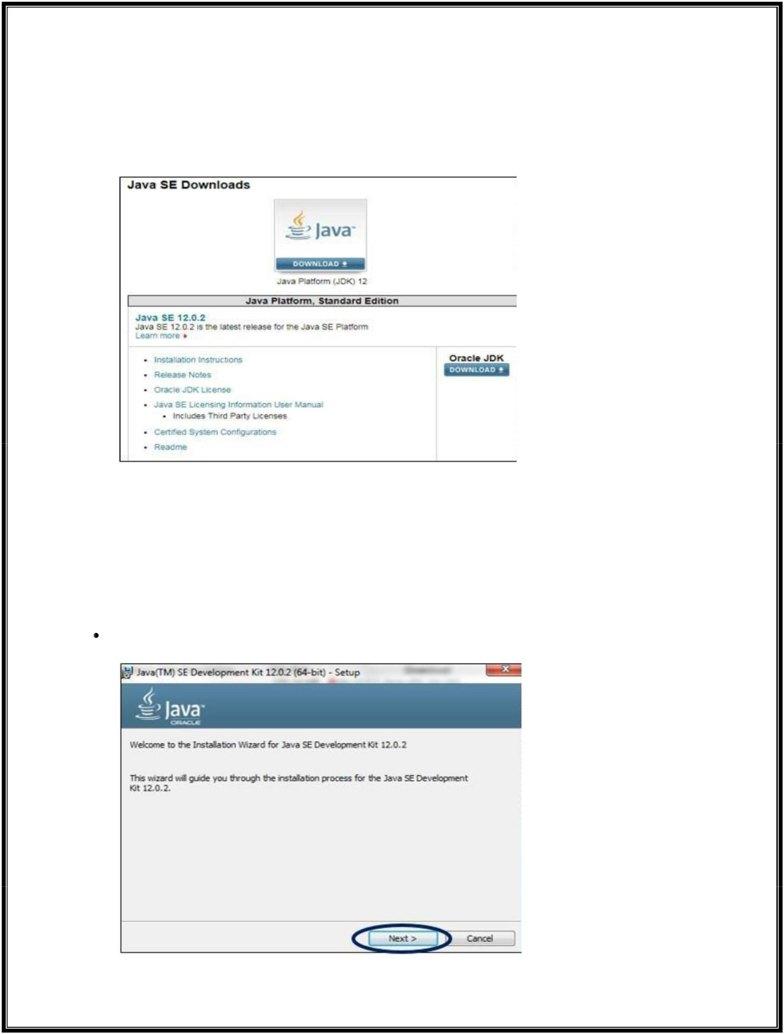

**JDK Installation**

***Step 1: Download JDK from the Site***

Go to the Oracle site and open the Java SE download page. Under the latest version of Java Platform, Standard Edition, click on the JDK download button.



Next, click on the Accept License Agreement button and choose your version of Java for Windows (32-bit or 64-bit) to proceed with downloading the JDK executable file.



***Step 2: Install the JDK exe File***

In this step, we will be running the executable JDK file (It will be a file with .exe as an extension) once the download is done. This installs JDK as well as JRE. For running this file on Windows, we will need Administrator rights.



To begin the installation, we need to double-click on the downloaded file, and we will be presented with the below window.

22Q71A4454

**Web Application Development Lab - R20**

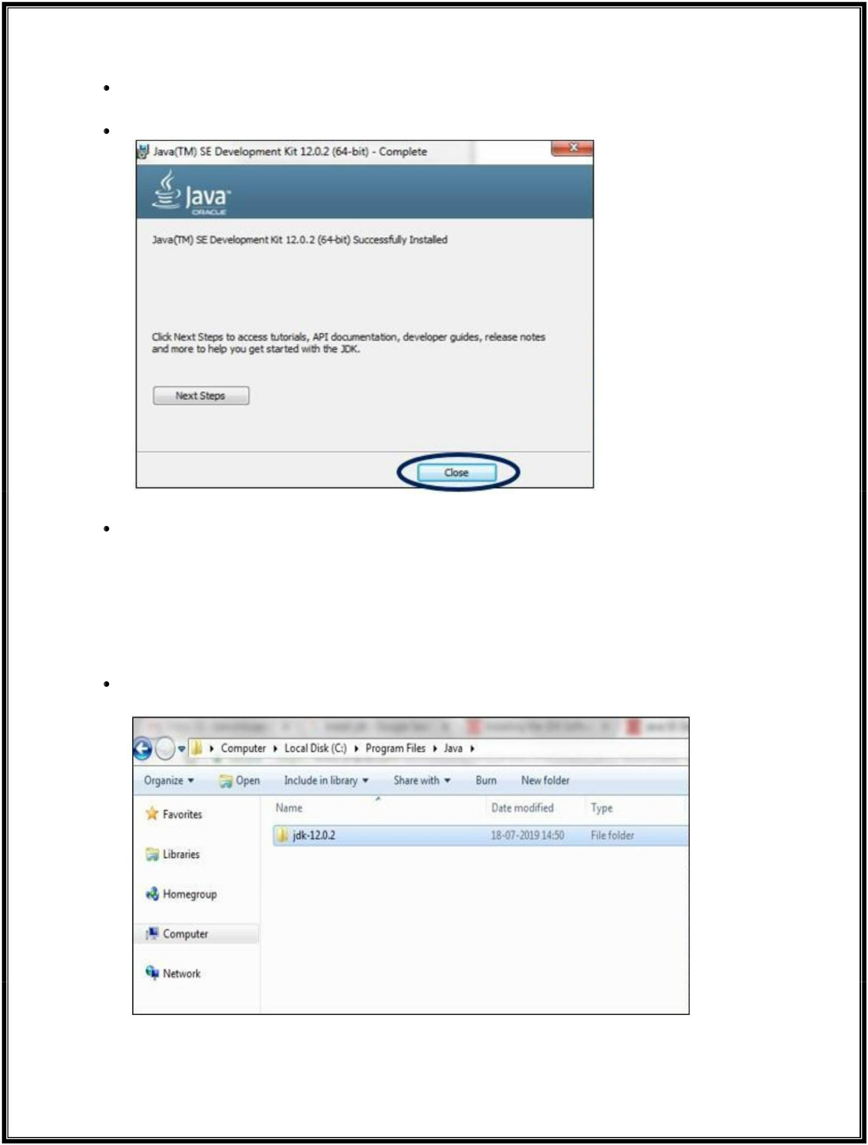

Click on Next to proceed with the installation, and follow the Installation guide provided for any queries.

Click on the Close button once the installation has finished.

To recover some of our system’s disk space, it is good practice to delete the downloaded exe file once the download has been done.

***Step 3: Check the Directory***

JDK gets installed in the C directory of our system by default having the path “C:\Program Files\Java\jdk-11.0”. If we make any change to this path at all, we need to make a note of it as it will be required in the upcoming steps.



This is the directory structure for our example.

22Q71A4454

**Web Application Development Lab - R20**

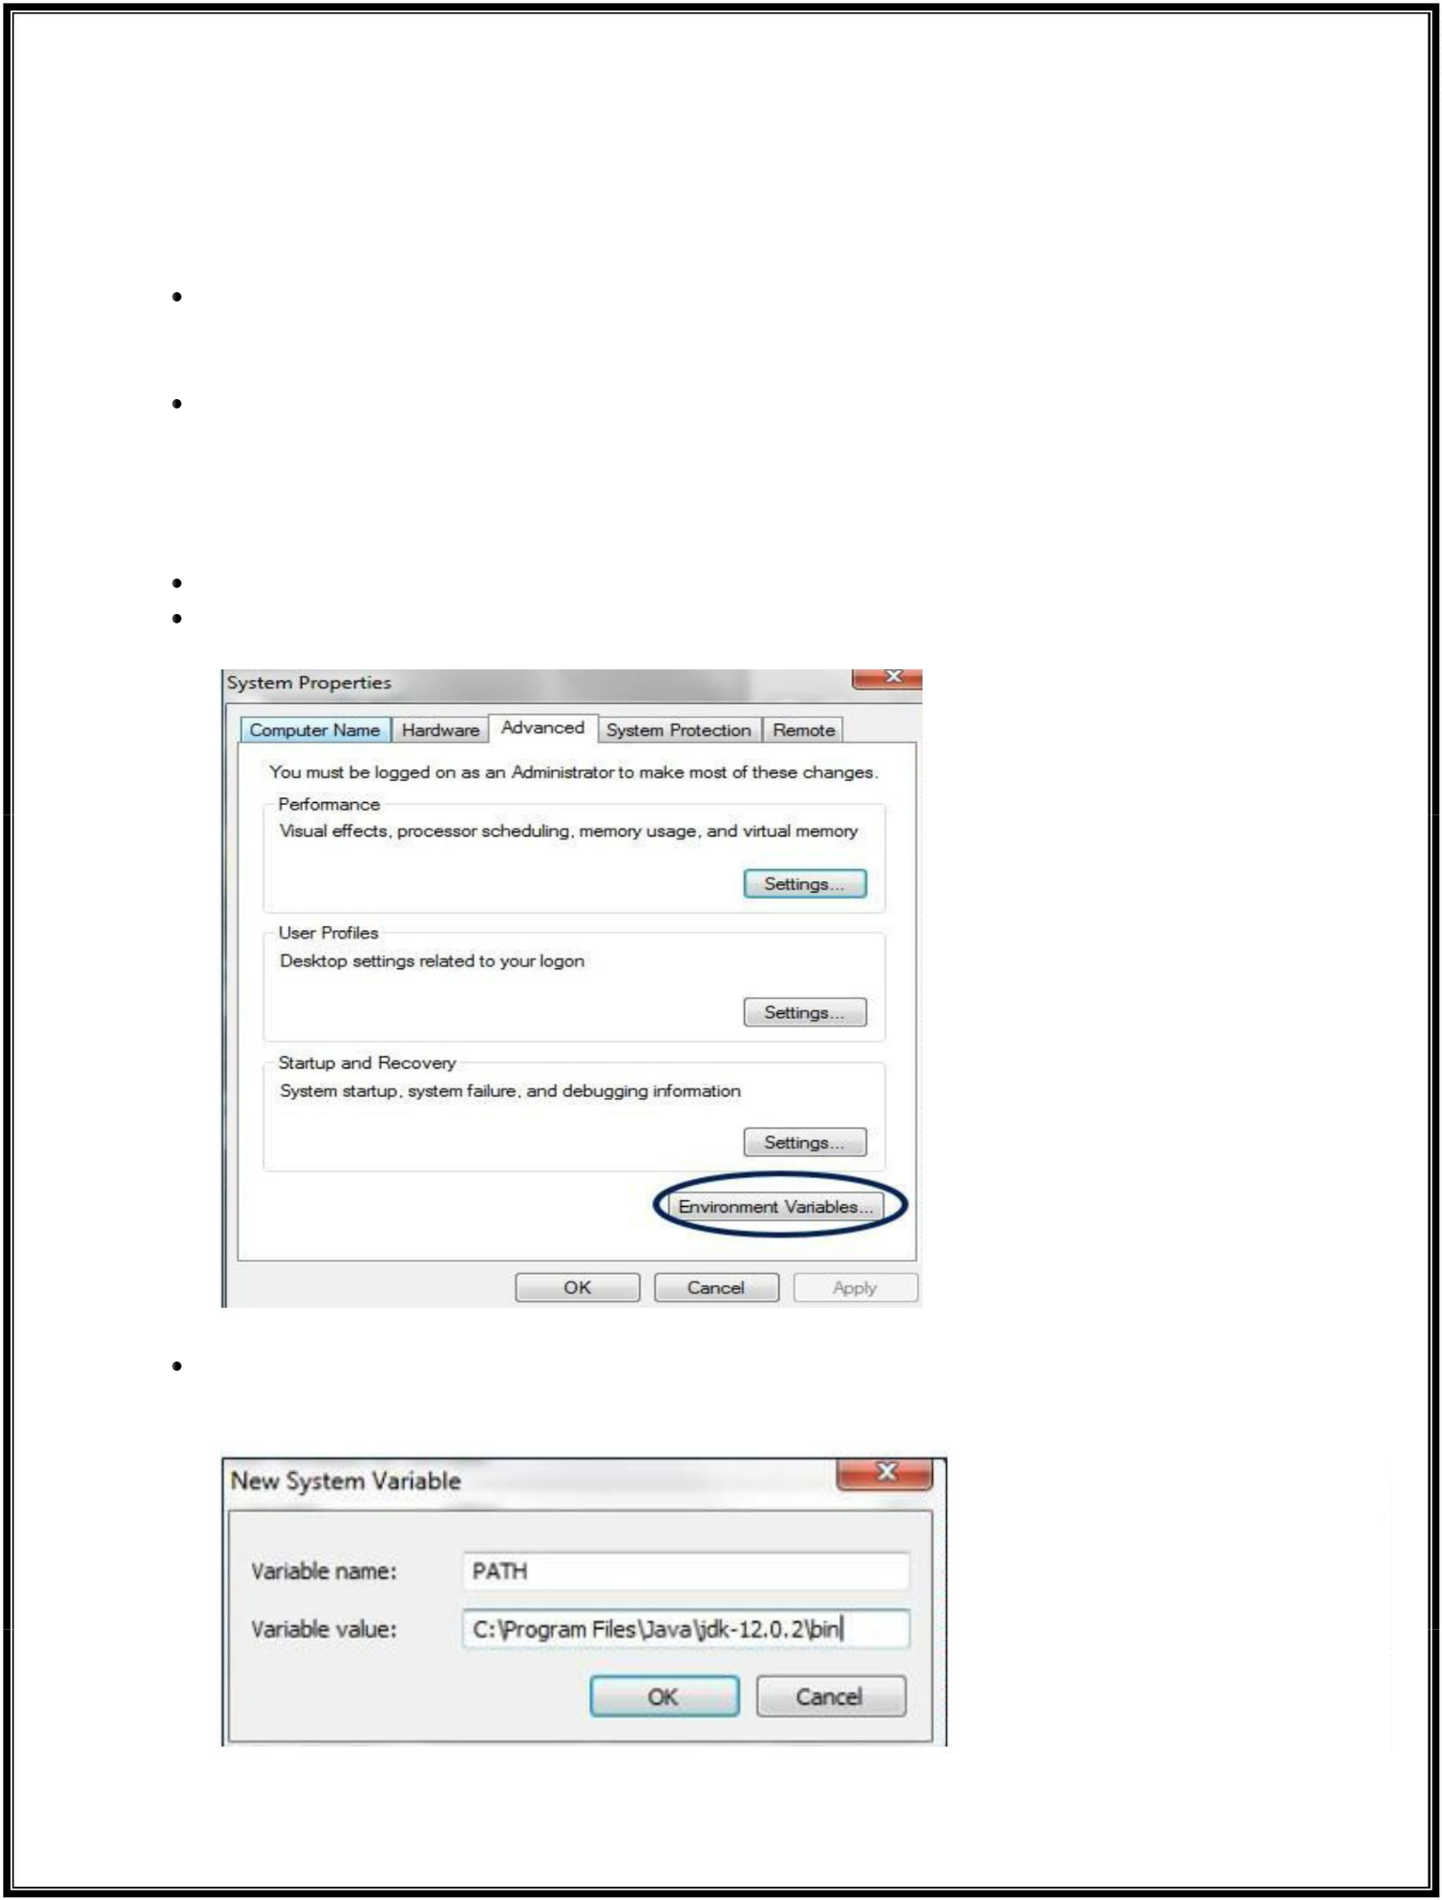

***Step 4: Update the Environment Variables***

We will need to update our system’s Environment variables with our installed JDK bin path to run the Java programs because while executing the programs, the command prompt will look for the complete JDK bin path.



The PATH variable in our system provides the exact location of executables that will be used for running Java programs, such as javac and java. The CLASSPATH variable provides us with the library files location.

If we do not set the PATH variable, we will specify the full path to the JDK bin every time we run a program.

**For example:** C:\> “C:\Program Files\Java\jdk-11.0\bin\javac” TestClass.java

So to set these variables, first right-click on My PC and select Properties.

Inside Properties, in the left-side panel, select Advanced System Settings, and here choose the option Environment Variables.

Click on New, and type PATH in the Variable Name, and enter the path of the bin of installed JDK in the Variable Value field**.**

22Q71A4454

**Web Application Development Lab - R20**



If we already have the PATH variable, we can edit it by adding it to the existing values.

Click on the OK button to apply the changes.

***Step 5: Verify the Java Installation***

Open the command prompt and enter the command “java –version”, and if it runs successfully, Java has been successfully installed.

Now that we have seen the steps to install JDK, let the programming fun begin!

22Q71A4454

**Web Application Development Lab - R20**

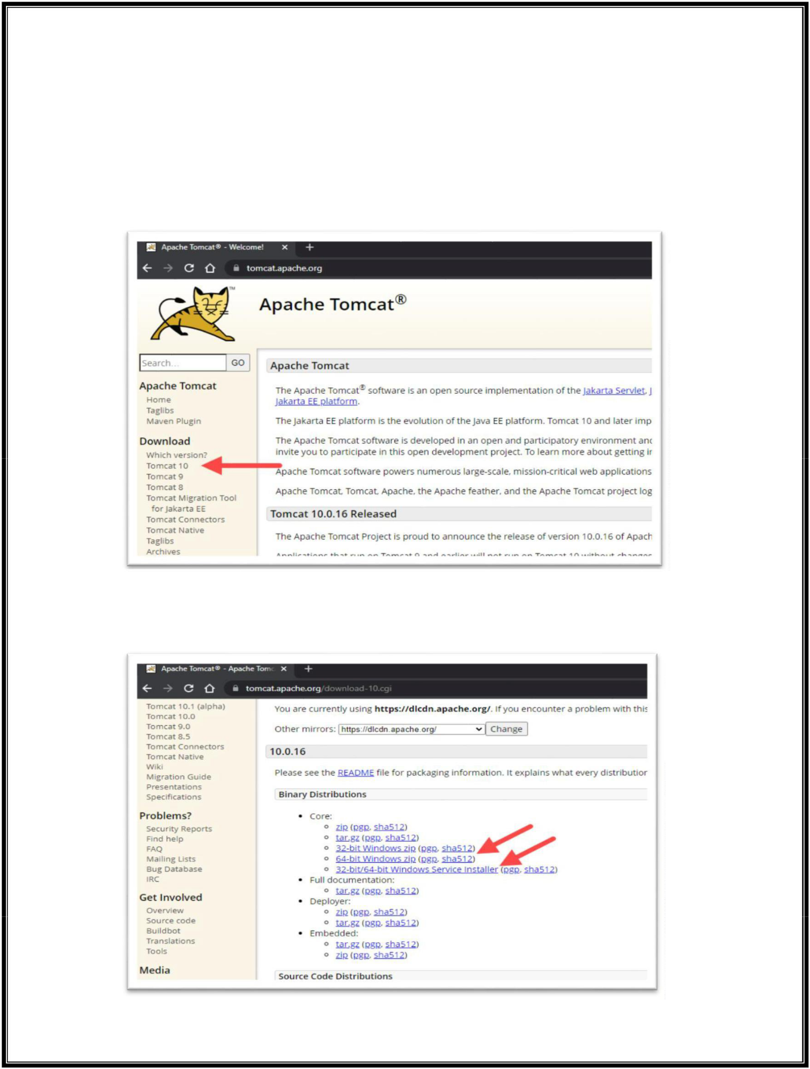

**Apache Tomcat Installation**

***Step 1: Download Tomcat for Windows***

To download the Tomcat installation file, follow the steps below:

1. Browse to the [official Apache Tomcat website.](https://tomcat.apache.org/) Locate the *Download* section and click the **latest Tomcat version** available. At the time of writing this article, the latest Tomcat version was version 10.
2. On the *Download* page, scroll down and locate the *Binary Distributions* area.

In the *Core* list, depending on the installation type you prefer, click the download link for the **Windows Service Installer** or the **32bit**/**64bit Windows zip file**.

22Q71A4454

**Web Application Development Lab - R20**

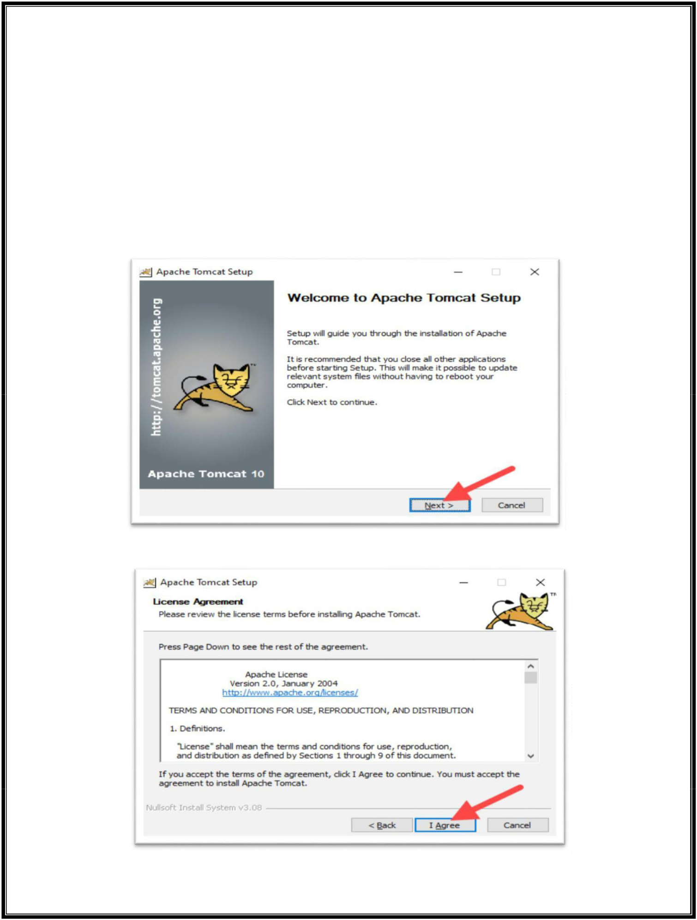

***Step 2: Install Tomcat***

Install Tomcat via the **Windows Service Installer** for an automated and wizard-guided experience. The service installer installs the Tomcat service and runs it automatically when the system boots.

For a portable experience, install Tomcat using the **zip file** and avoid installing the service. Easily uninstall Tomcat when it is no longer needed by deleting the Tomcat directory, or move it around when necessary.

Follow the steps below to install Tomcat using the Windows Service Installer.

1. Open the downloaded **Windows Service Installer** file to start the installation process.
2. In the Tomcat Setup welcome screen, click **Next** to proceed.
3. Read the License Agreement and if you agree to the terms, click **I Agree** to proceed to the next step.

22Q71A4454

**Web Application Development Lab - R20**

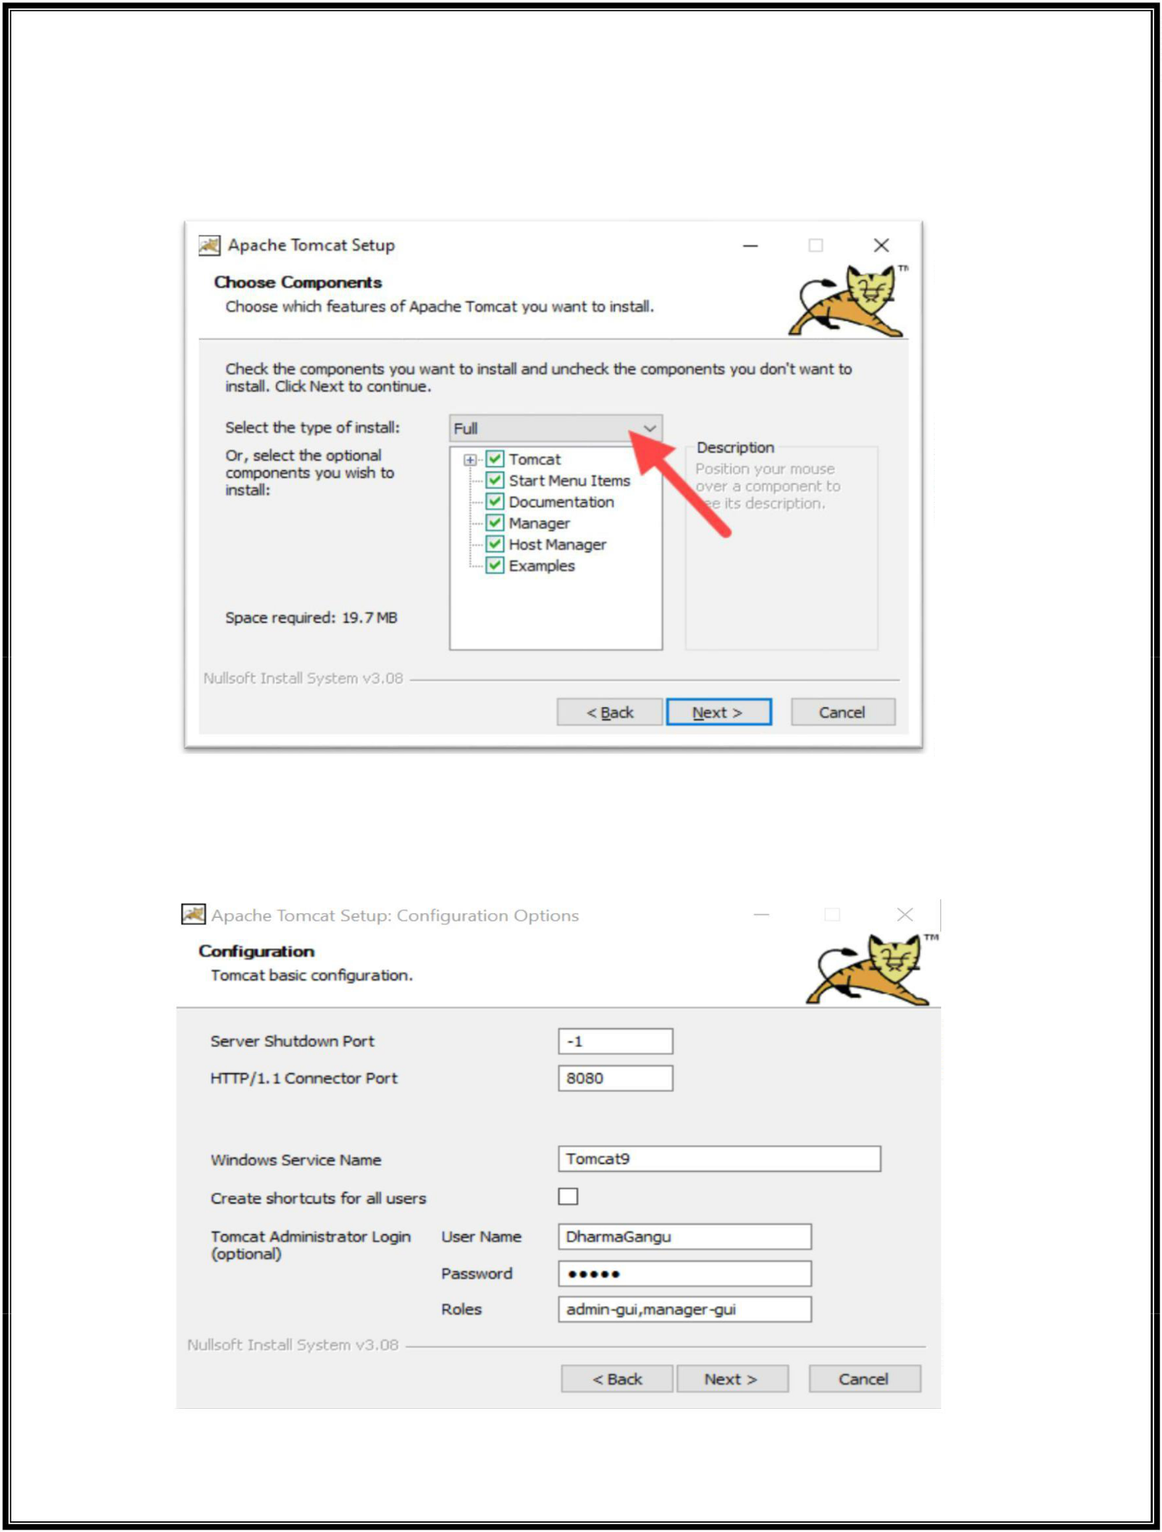

1. In the Tomcat component selection screen, choose **Full** in the In the Tomcat component selection screen, choose **Full** in the dropdown menu to ensure the wizard installs the

Tomcat Host Manager and Servlet and JSP examples web applications. Alternatively, keep

the default **Normal** installation type and click **Next**.

1. The next step configures the Tomcat server. For instance, enter the **Administrator login credentials** or choose a different **connection port**. When finished, click **Next** to proceed to the next step.

22Q71A4454

**Web Application Development Lab - R20**

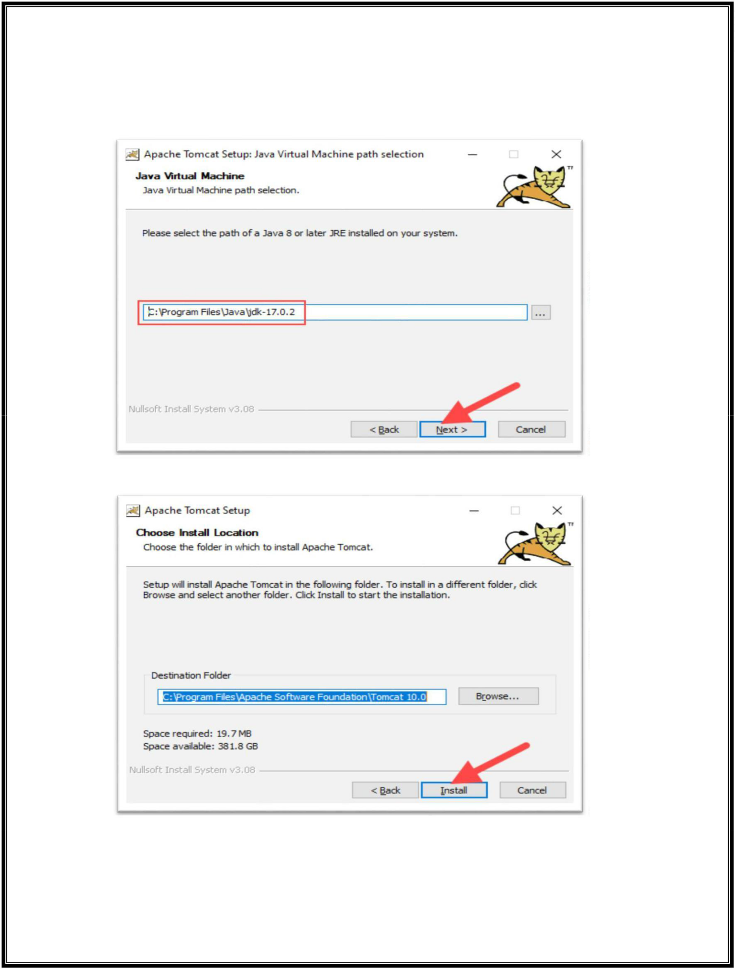

1. The next step requires you to enter the full path to the JRE directory on your system. The wizard auto-completes this if you have previously [set up the Java environment variables.](https://phoenixnap.com/kb/install-java-windows#ftoc-heading-6) Click **Next** to proceed to the next step.

7. Choose the Tomcat server install location or keep the default one and click **Install**.

1. Check the **Run Apache Tomcat** box to start the service after the installation finishes. Optionally, check the **Show Readme** box to see the Readme file. To complete the installation, click **Finish**.

22Q71A4454

**Web Application Development Lab - R20**

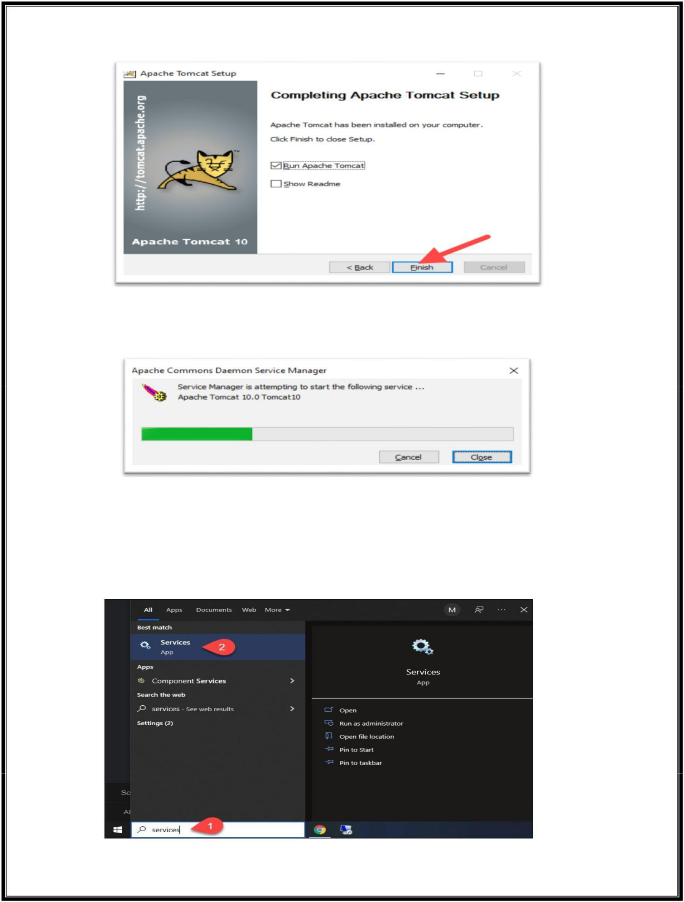

1. A popup window appears that starts the Tomcat service. After the process completes, the window closes automatically. The Apache Tomcat web server is now successfully installed .

***Step 3: Check if Apache Tomcat Service Is Running***

Installing Tomcat using the Windows Service Installer installs Tomcat as a Windows service that automatically runs on boot. Follow the steps below to ensure that Tomcat is started as a Windows service.

1. Open the **Start** menu and search for *Services*.
2. Select the **Services** result.

22Q71A4454

**Web Application Development Lab - R20**

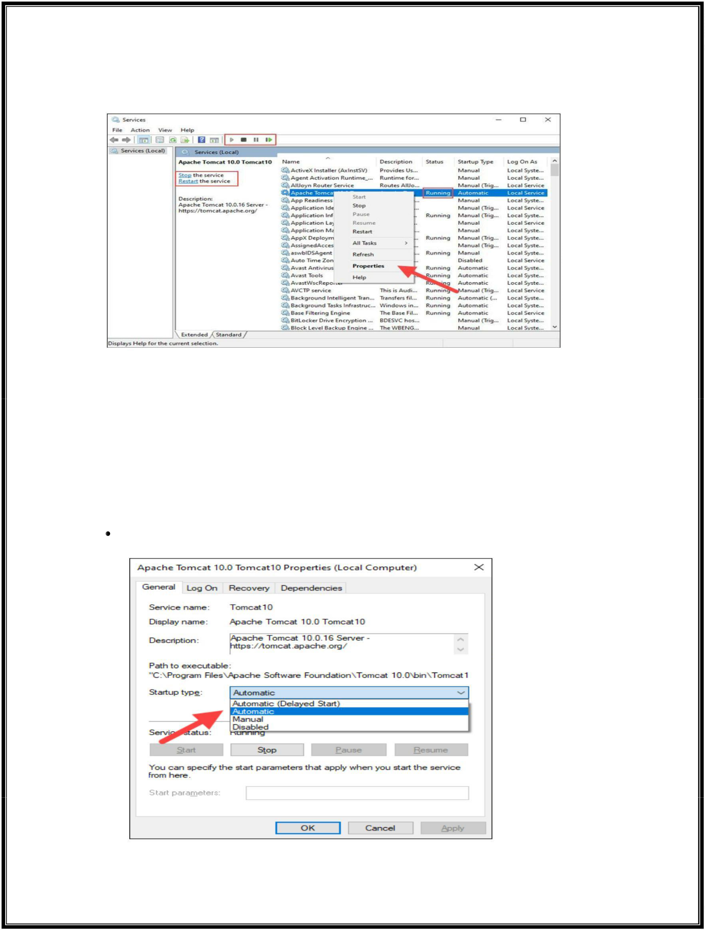

1. In the *Services* window, locate the *Apache Tomcat* service. The *Status* column indicates whether the service is running or not. **Start** or **Stop** the service using the buttons in the toolbar or by pressing **Stop** or **Restart** on the left side of the service list.

Configure the service startup by right-clicking the Tomcat service and selecting Properties.

1. In the *Properties* window, under the *Startup type* dropdown menu, select how to run the Tomcat service:

Automatic (Delayed Start). Starts the service shortly after boot. A delayed start improves server boot performance and has security benefits.



Automatic. Automatically starts the service on boot.



Manual. The service starts only when Windows or another service needs it or if invoked.



Disabled. Disables the service startup, even if you try to start it.

Click **OK** to confirm the changes.

22Q71A4454

**Web Application Development Lab - R20**

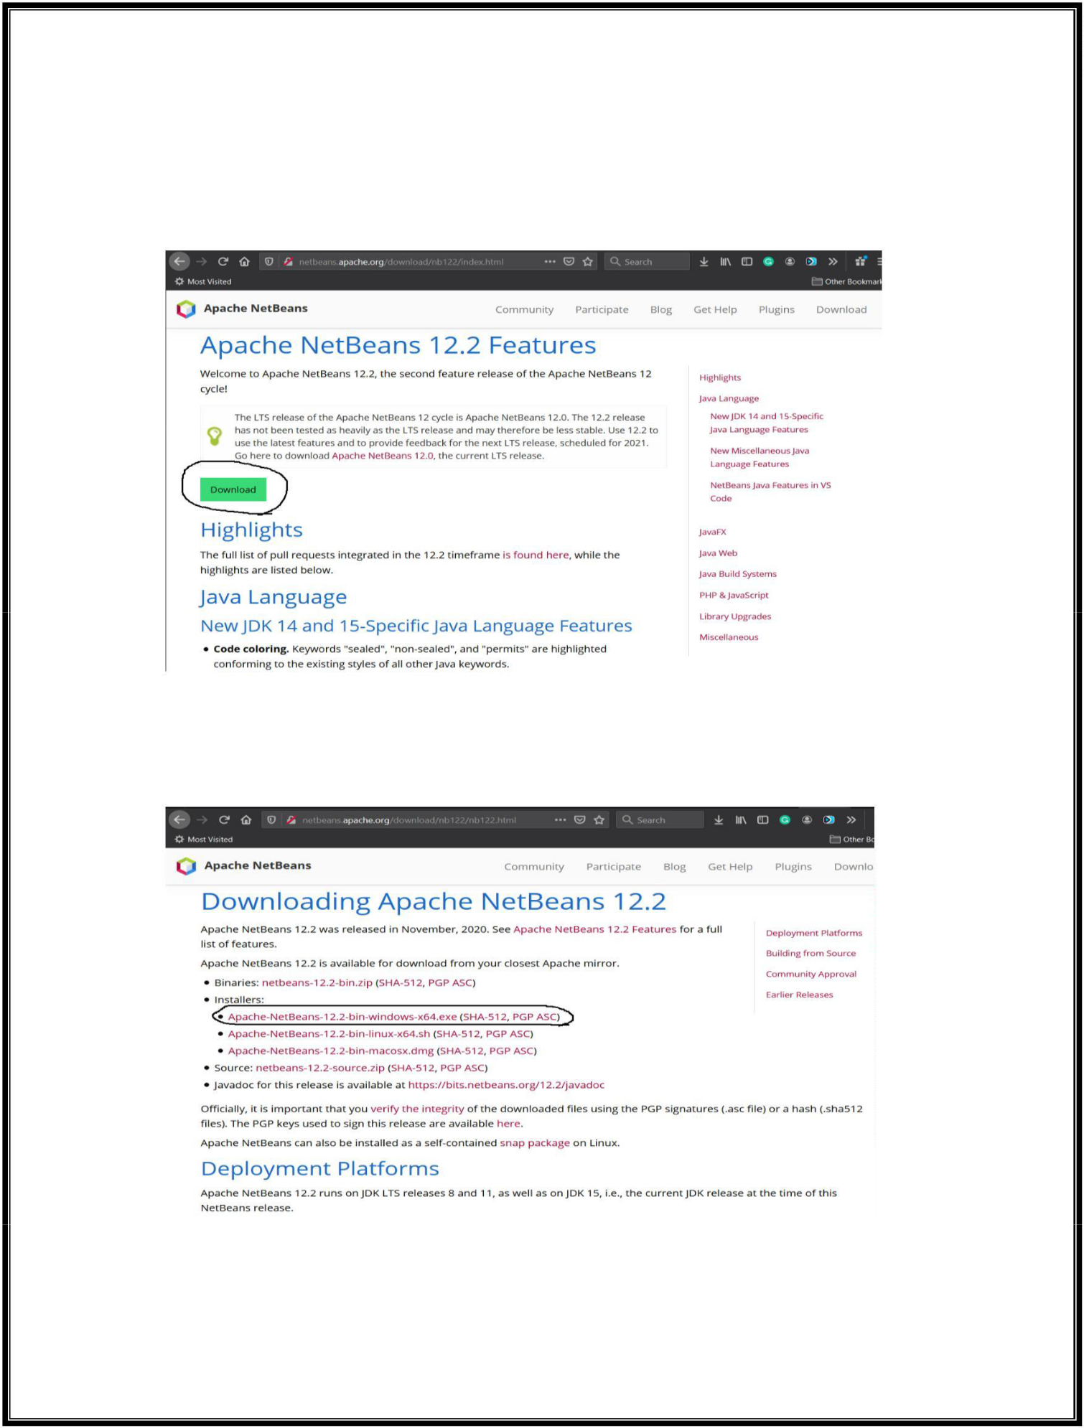

**Net Beans Installation (Exp – 1 to 3)**

***Step 1: Download NetBeans 12***

1. Click the **Find Out More Button** as shown in Fig. It will navigate to the NetBeans Features Page as shown in below Fig.
2. Now click the **Download Button** to navigate to the Downloads Page of NetBeans as shown in below Fig.

22Q71A4454

**Web Application Development Lab - R20**

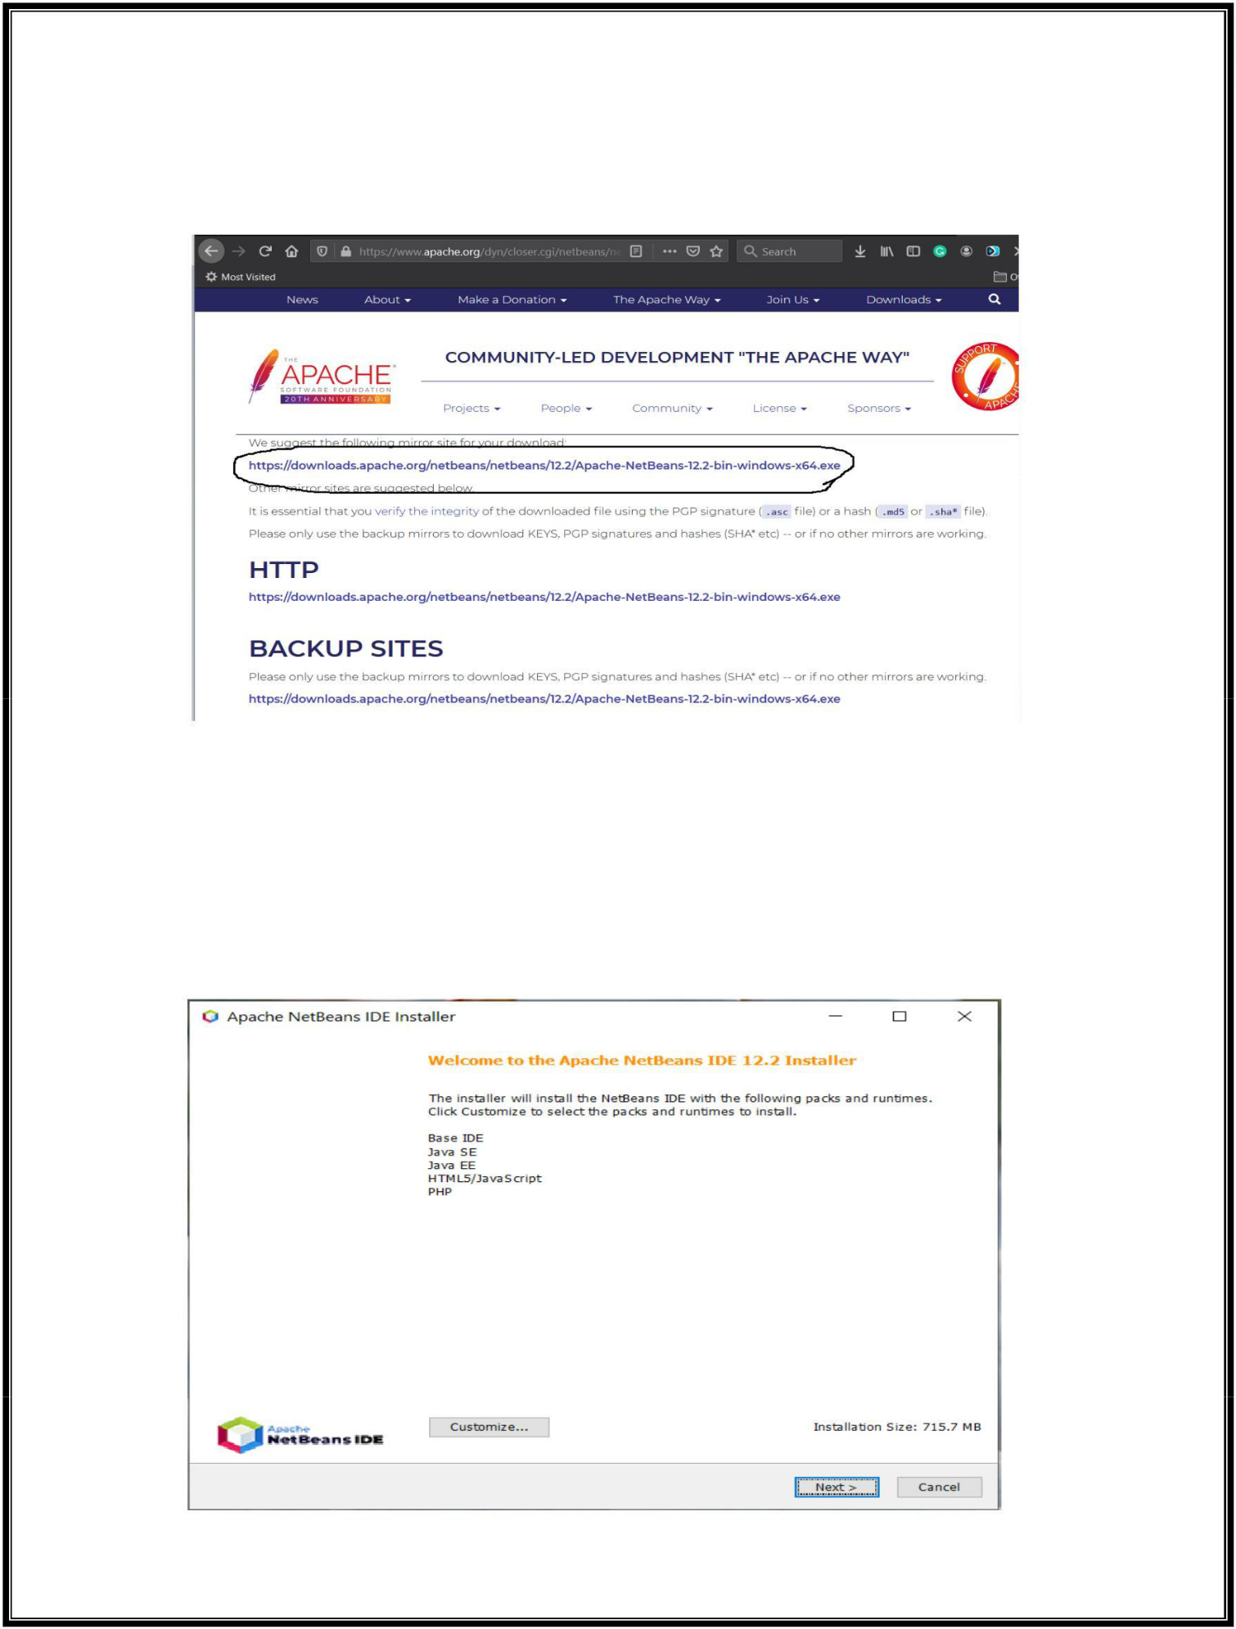

1. I have highlighted the download options for windows using the installer. Now click the **Windows Installer Link**. It will open the page having download links from the mirror sites as shown in below Fig.
2. Now click the suggested download link as highlighted in above Fig . It will start downloading the most recent release of NetBeans 12.

***Step 2: Install NetBeans 12***

1. Execute the installer to start installing **NetBeans on Windows**. It will ask for system permissions to continue the installation. Click the **Yes Button** to continue the installation.

Next, it will show the **Welcome Screen** having options to choose the components as shown in below Fig.

22Q71A4454

**Web Application Development Lab - R20**

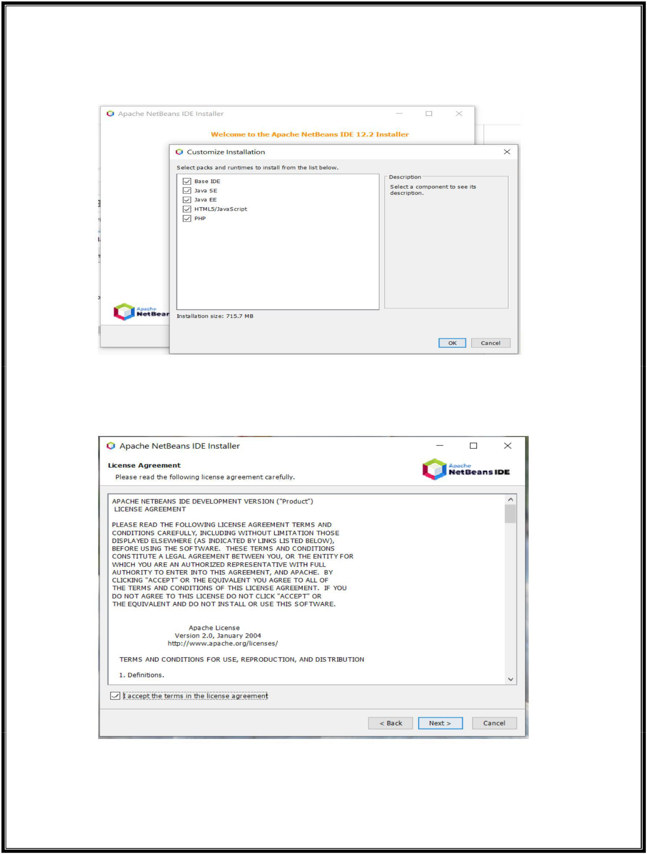

1. It provides options to customize the components to be installed using the **Customize Button** as shown in below Fig.
2. I kept all the components selected and clicked the **Next Button** to continue the installation. The installer asks to accept the **License Agreement** on the next screen as shown in next Fig.

22Q71A4454

**Web Application Development Lab - R20**

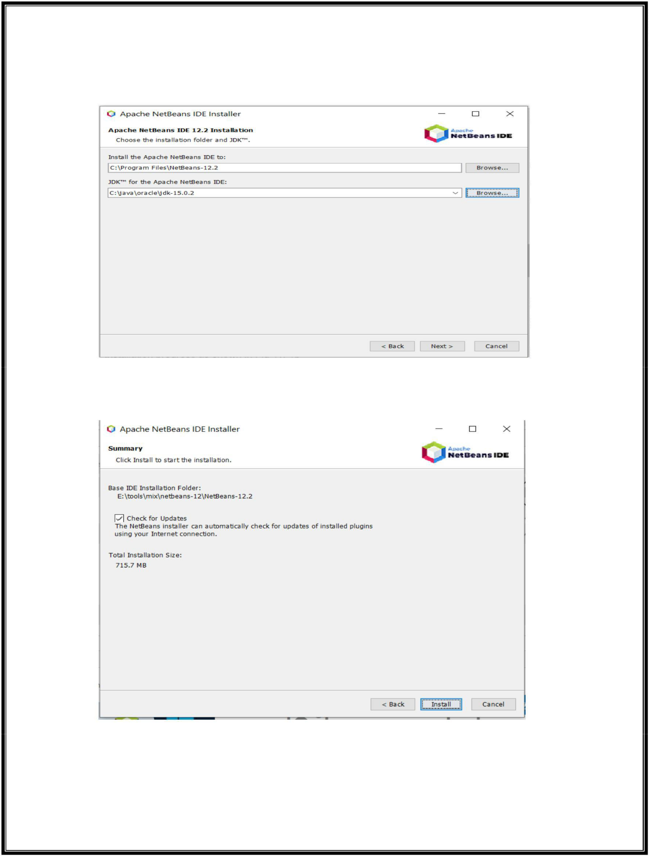

1. Now click the **Next Button** to configure the installation path and JDK path as shown in below Fig.
2. Click the **Next Button** to progress the installation. The next screen shows the installation summary and provides options to get updates as shown in below Fig.
3. Now click the **Install Button** to start the installation. It will show the installation progress as shown in below Fig.

22Q71A4454

**Web Application Development Lab - R20**

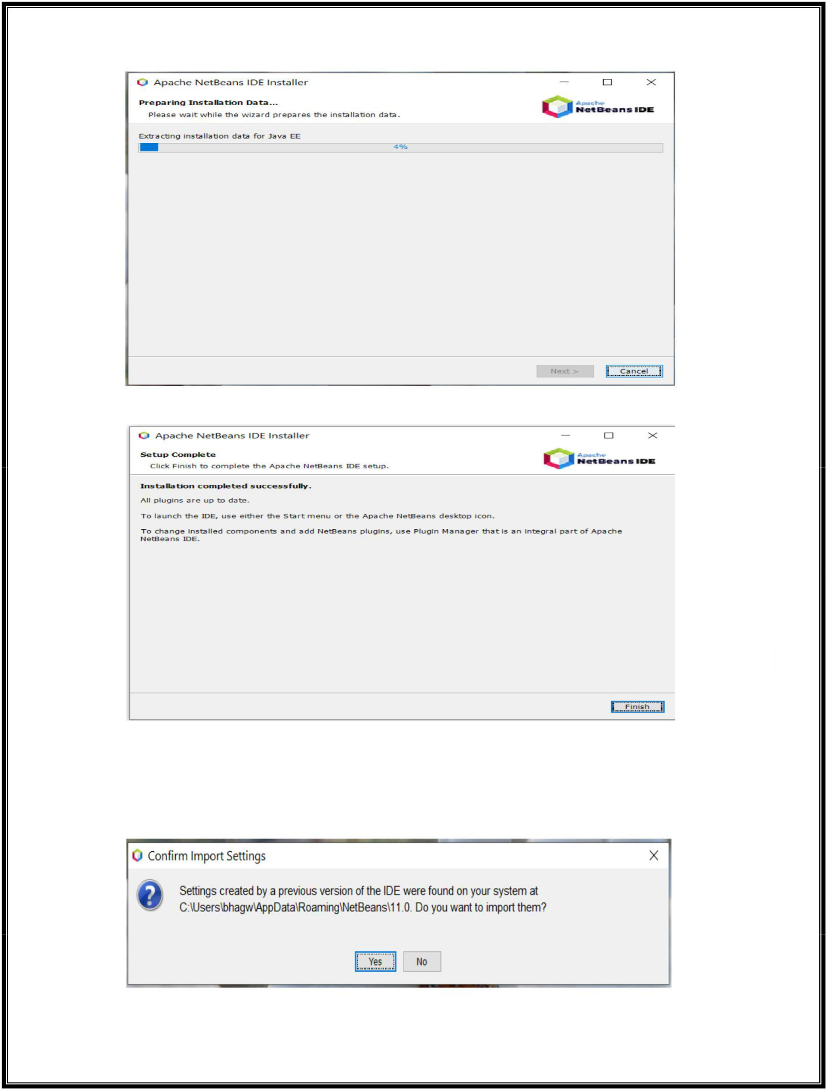

It will show the **Success Screen** after completing the installation as shown in below Fig

1. Now click the **Finish Button** to close the installer.

***Step 3: Launch the IDE***

1. We can launch the IDE using the launcher icon placed on the Desktop. It might ask to import settings from the old installation as shown in below Fig .

22Q71A4454

**Web Application Development Lab - R20**

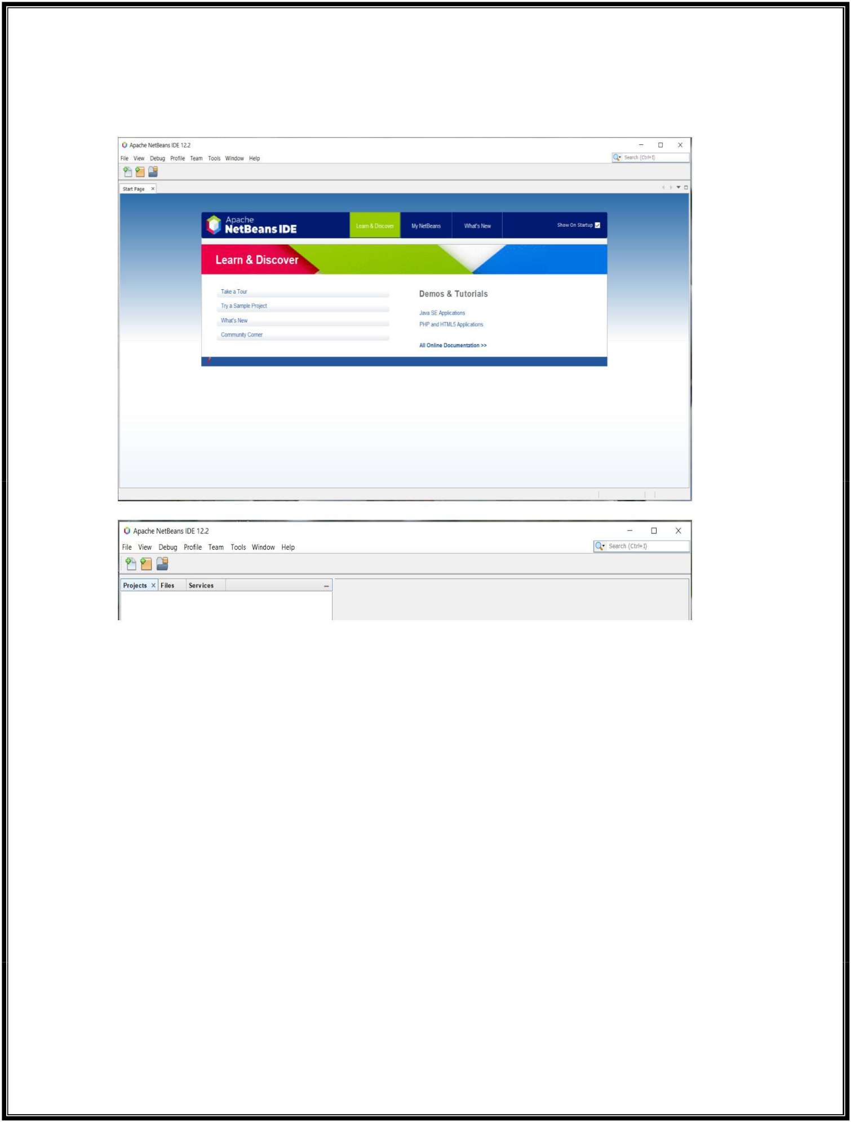

1. Choose the appropriate option. It will start the IDE and shows the **Welcome Screen** and the **Default Layout** as shown in next two Fig’s.

22Q71A4454

**Web Application Development Lab - R20**

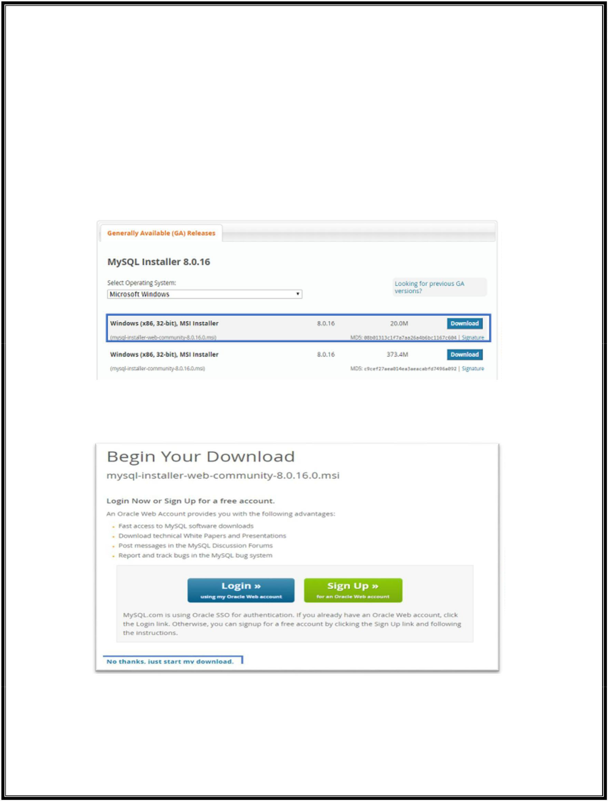

**Installation of MySQL – MySQL Installer (Exp - 3)**

**Step 1:** Go to the [**official website of MySQL**](https://dev.mysql.com/downloads/installer/) and scroll down. Then you will see an option to choose the Operating System. Here I will choose Windows.

**Step 2:** After that, you will see two options to Download. If you have internet connectivity then you can go forward and choose the *mysql-installer-web-community,* else you can choose the other one. Refer below.

**Step 3:** Once, you click on Download, you will be redirected to the following page:

In the above page, just click on the option of “**No thanks, just start my download**.” Once, you click on this option, you will see that **MySQL Installer is getting downloaded.**

22Q71A4454

**Web Application Development Lab - R20**

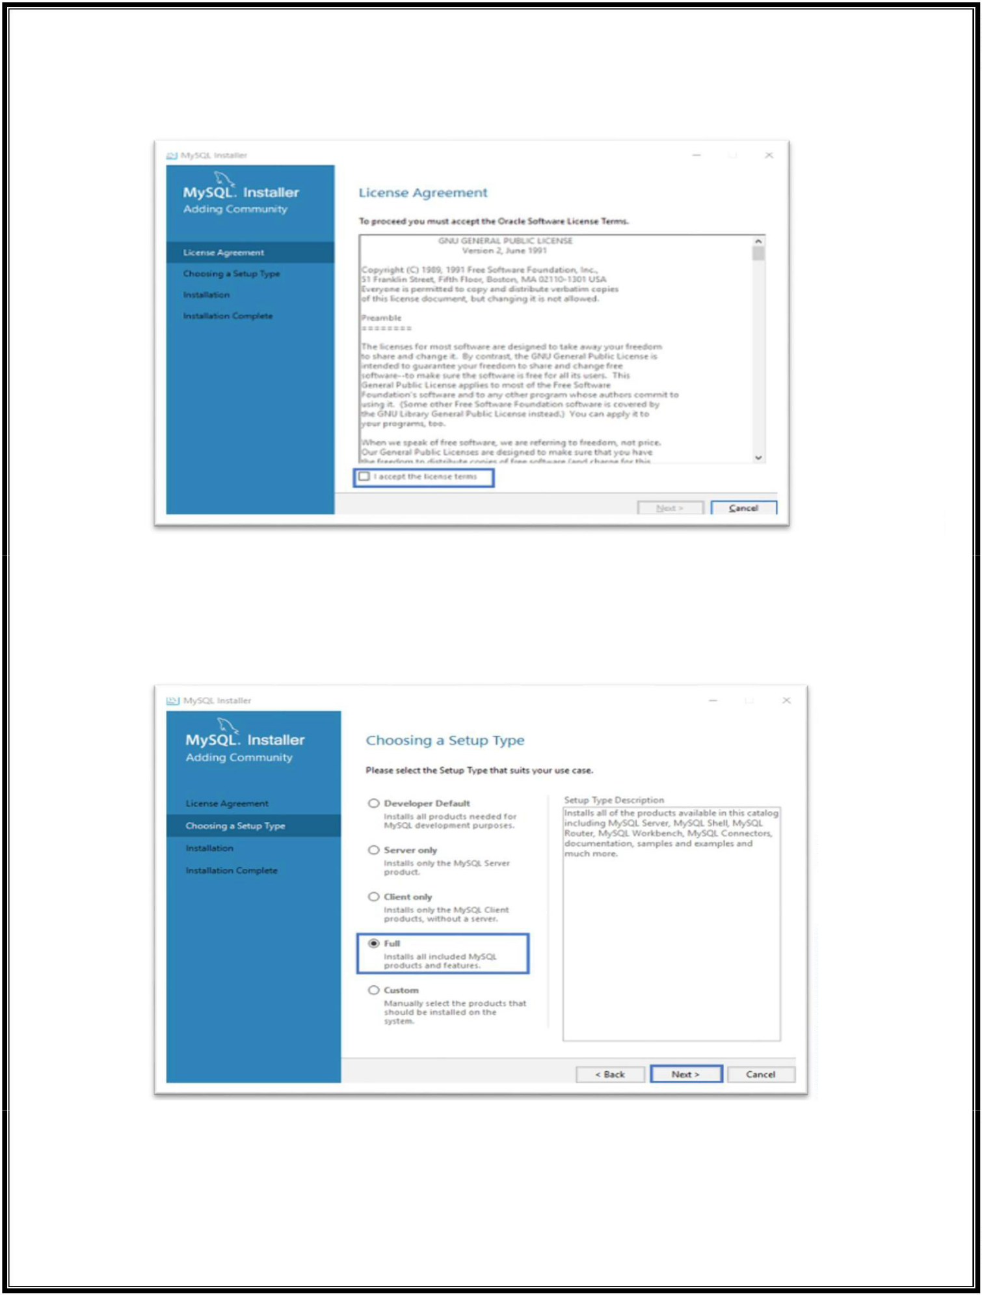

**Step 4:** After MySQL Installer gets downloaded, double click on it, and you will see that the MySQL installer Community is getting installed. Once, it is downloaded you will see the following screen.

In the above dialog box, just check in in the radio button and accept the License Agreement. After that, click on **Next.**

**Step 5:** In the next wizard, you have to choose the **setup type**. Basically, this is where you choose which features you wish to install. Here I will choose the option **Full** and click on **Next.**

This option will MySQL Server, MySQL Shell, MySQL Router, MySQL Workbench, MySQL Connectors, documentation, samples and examples and much more.

22Q71A4454

**Web Application Development Lab - R20**

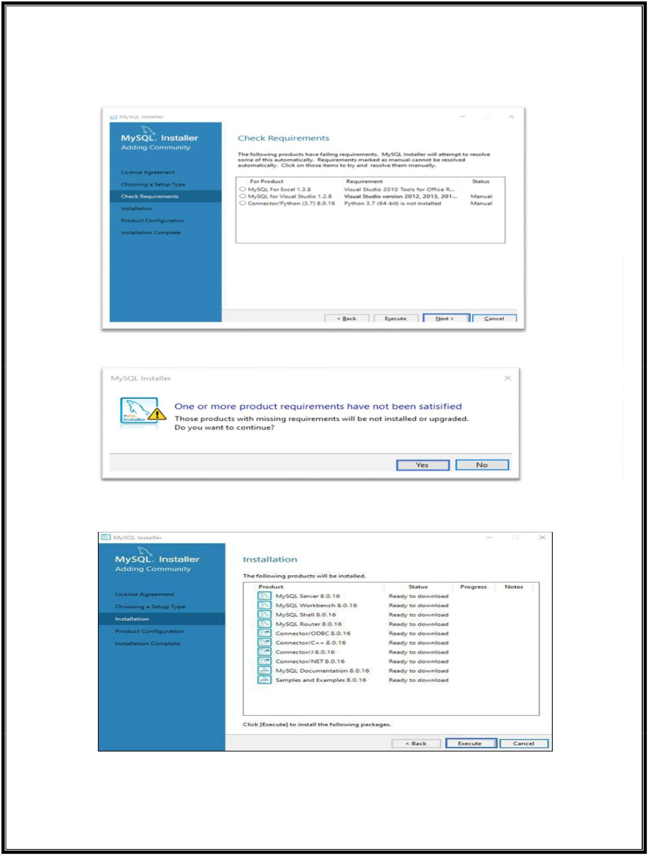

**Step 6:** Once you click on **Next**, you might see that some features may fail to install due to lack of requirements. So, either you can resolve them, or can skip them, by clicking on **Next**. Here I will click on **Next.**

**Step 6.1:** Next, you will see a dialog box asking for your confirmation of a few products not getting installed. So, you can just click on **Yes.** Refer below.

As soon as you click on **Next**, you will see the list of the products which will get installed. So, if you are fine with the products, go ahead and click on **Execute** as below.

Once you hit on Execute, you will see that the products are getting installed. Refer below:

22Q71A4454

**Web Application Development Lab - R20**

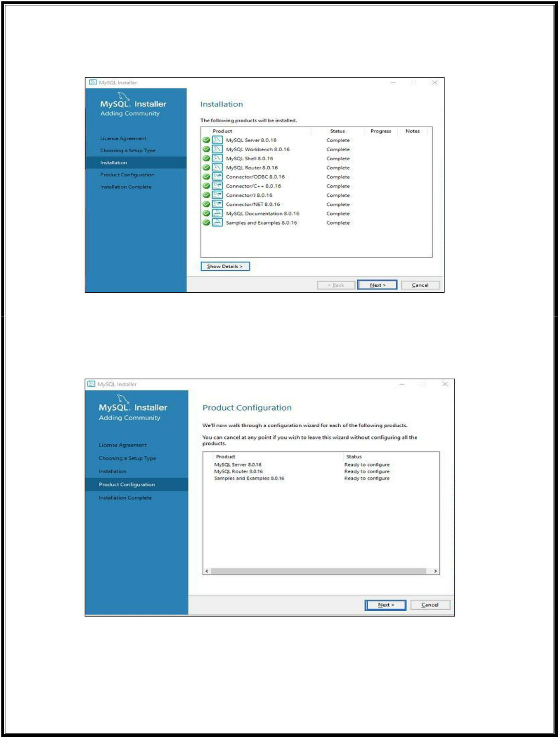

Now, once the installation is complete, click on **Next.**

**Server Configuration**

Next, you have to configure the Server and Router. Well, over here let me tell you that, I am not going to configure the Router now since it is not required to simply use MySQL. But, I will show you how to configure Server. So, in the below dialog box, click on **Next.**

22Q71A4454

**Web Application Development Lab - R20**

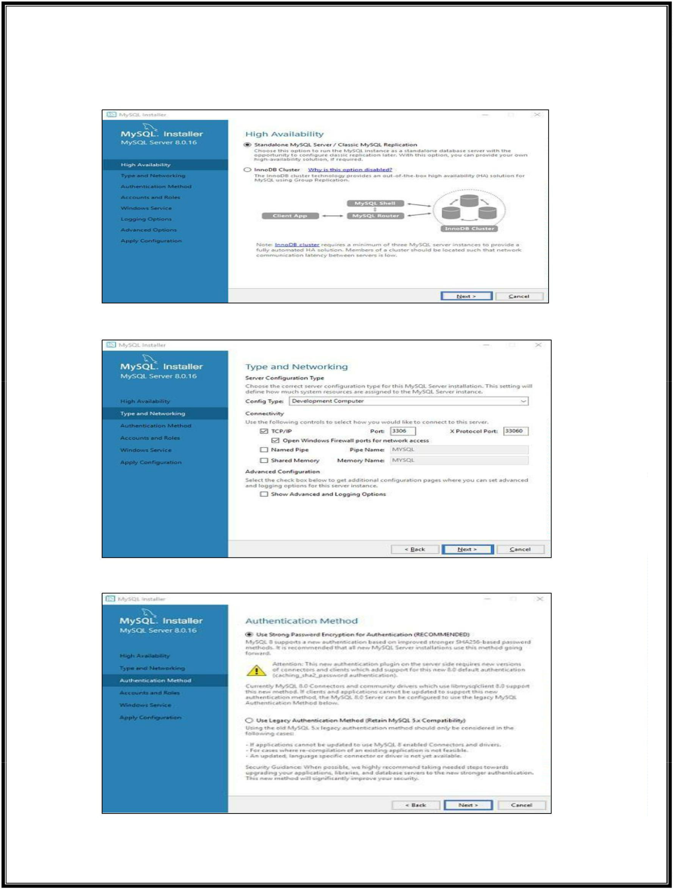

**Step 7:** In the below wizard, you can either choose the **Standalone MySQL Replication or the InnoDB Cluster** based on your requirement. Here I will choose, Standalone MySQL Cluster and then click on **Next.**

**Step 8:** Once, you click on Next, you have to mention the **server configuration**. So, I will leave it as it is and then click on **Next.**

**Step 9:** Now, you have to choose the authentication method. Here, I will choose the first option and click on **Next**. Refer below.

22Q71A4454

**Web Application Development Lab - R20**

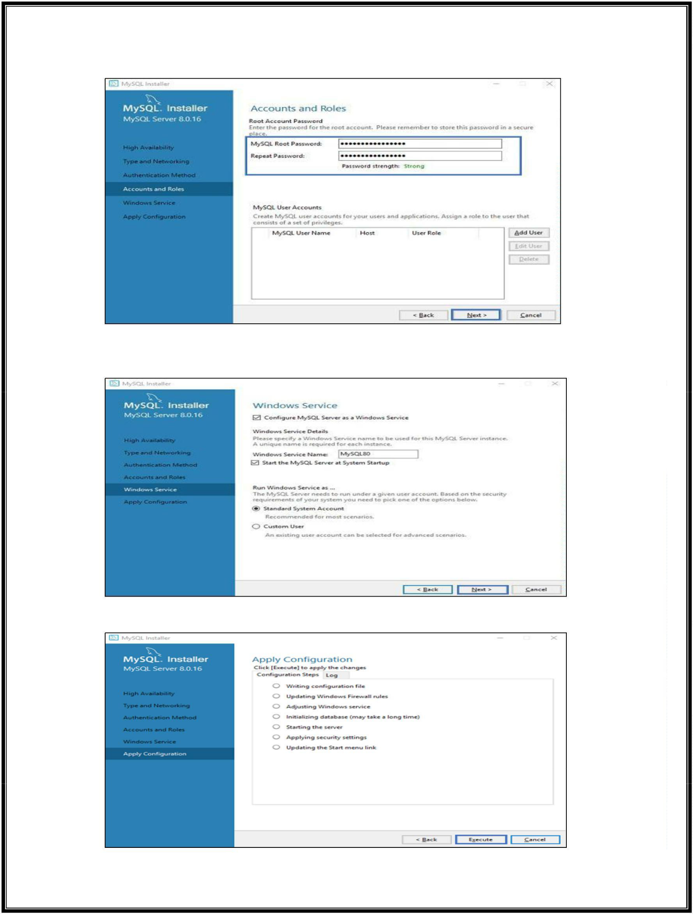

**Step 10:** Next, you have to mention the MySQL Root Password and again click on **Next.**

**NOTE:** Please make a note of this password.

**Step 11:** Finally, you have to choose whether you want to start the server or not. Here, I am going to leave it as it is. Then, click on **Next.**

Now, the wizard will give you a list of the configurations which will be applied. So, if you agree with the configuration click on **Execute.**

22Q71A4454

**Web Application Development Lab - R20**

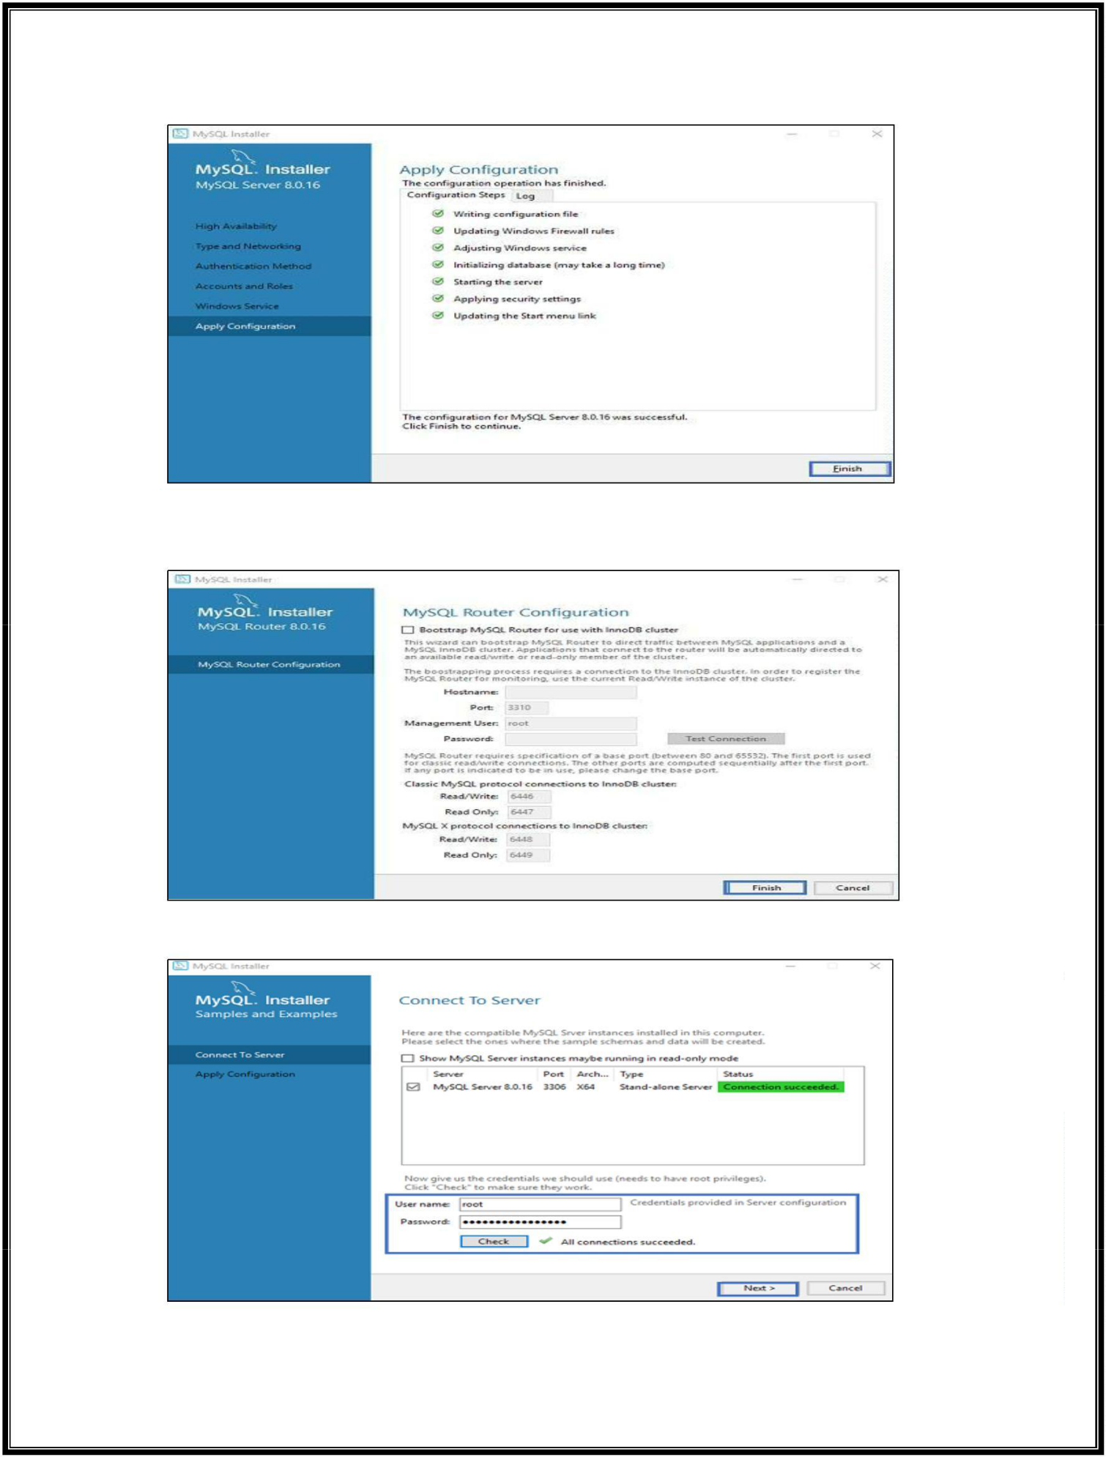

Once the execution is done, click on **Finish**. This will finish the configuration of Server.

**Step 12:** In the next wizard that comes up, you can choose to configure the Router. So just click on **Next** and click on **Finish.**

**Step 13:** Once, you click on **Finish**, you will see the following wizard, to **Connect to server**. Here mention the root password, which you had set in the previous steps. Refer below.

Check if the connection is successful, by clicking on the **Check button** and then click on **Execute.** Now, once the configuration is complete click on **Next.**

22Q71A4454

**Web Application Development Lab - R20**

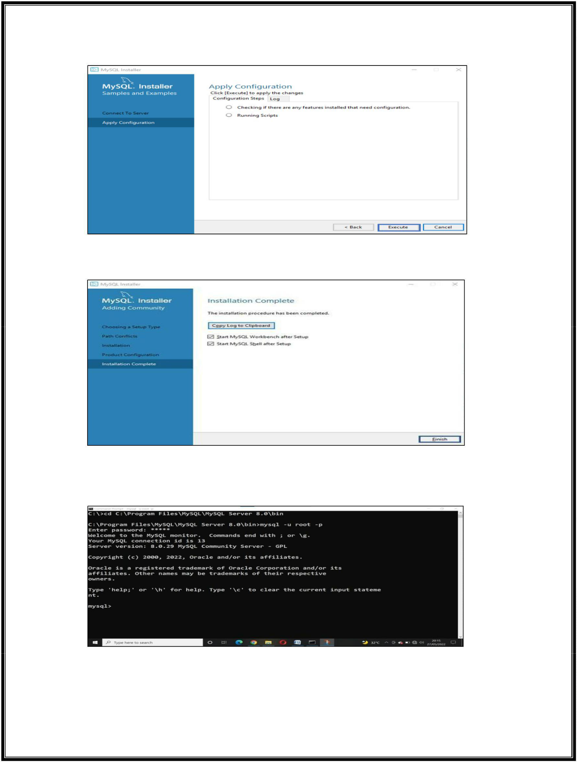

**Step 14:** Once, you click on **Next**, choose the configurations applied and click on **Execute.**

After the configurations get applied, you will see the following screen. So, here just click on **Finish**.

Refer below.

**Check Whether MySQL Is Installed Or Not**

**Step 15:** Now, to check whether MySQL is installed or not, you can open the MySQL Shell and mention the root password.

The above output indicates that MySQL has been installed in your system. Now, that you know how to install MySQL if you wish to know about the GUI of MySQL, you can refer to my article on [MySQL](https://www.edureka.co/blog/mysql-workbench-tutorial) [Workbench.](https://www.edureka.co/blog/mysql-workbench-tutorial)

22Q71A4454

**Web Application Development Lab - R20**

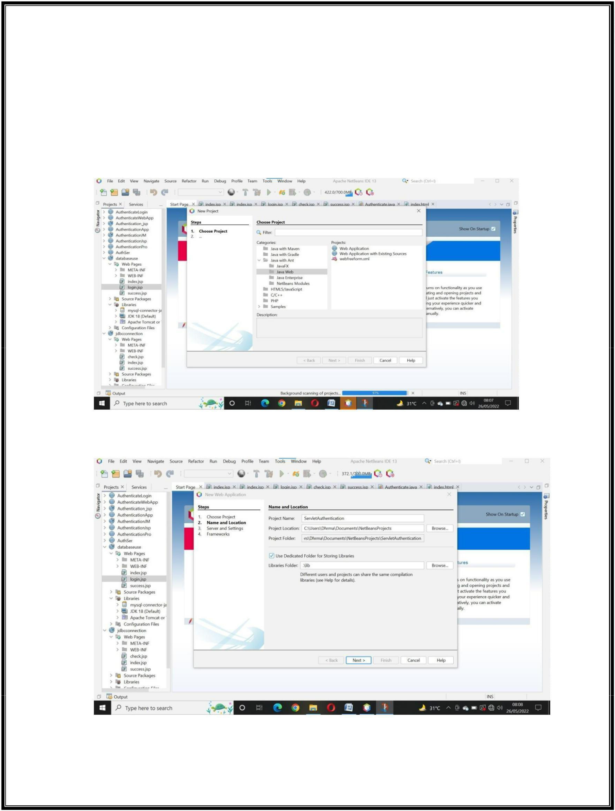

**Experiment – 1**

**Aim: Authentication Using Servelet**

**Solution:**

**Step 1:** Go to ***File*** -> click on ***New Project*** ->select ***Java Web*** from ***Categories*** and select ***web Application*** from ***Projects***-> click on ***Next***.

**Step 2**: Enter the Proper ***Project Name*** -> click on ***Next***.

22Q71A4454

**Web Application Development Lab - R20**

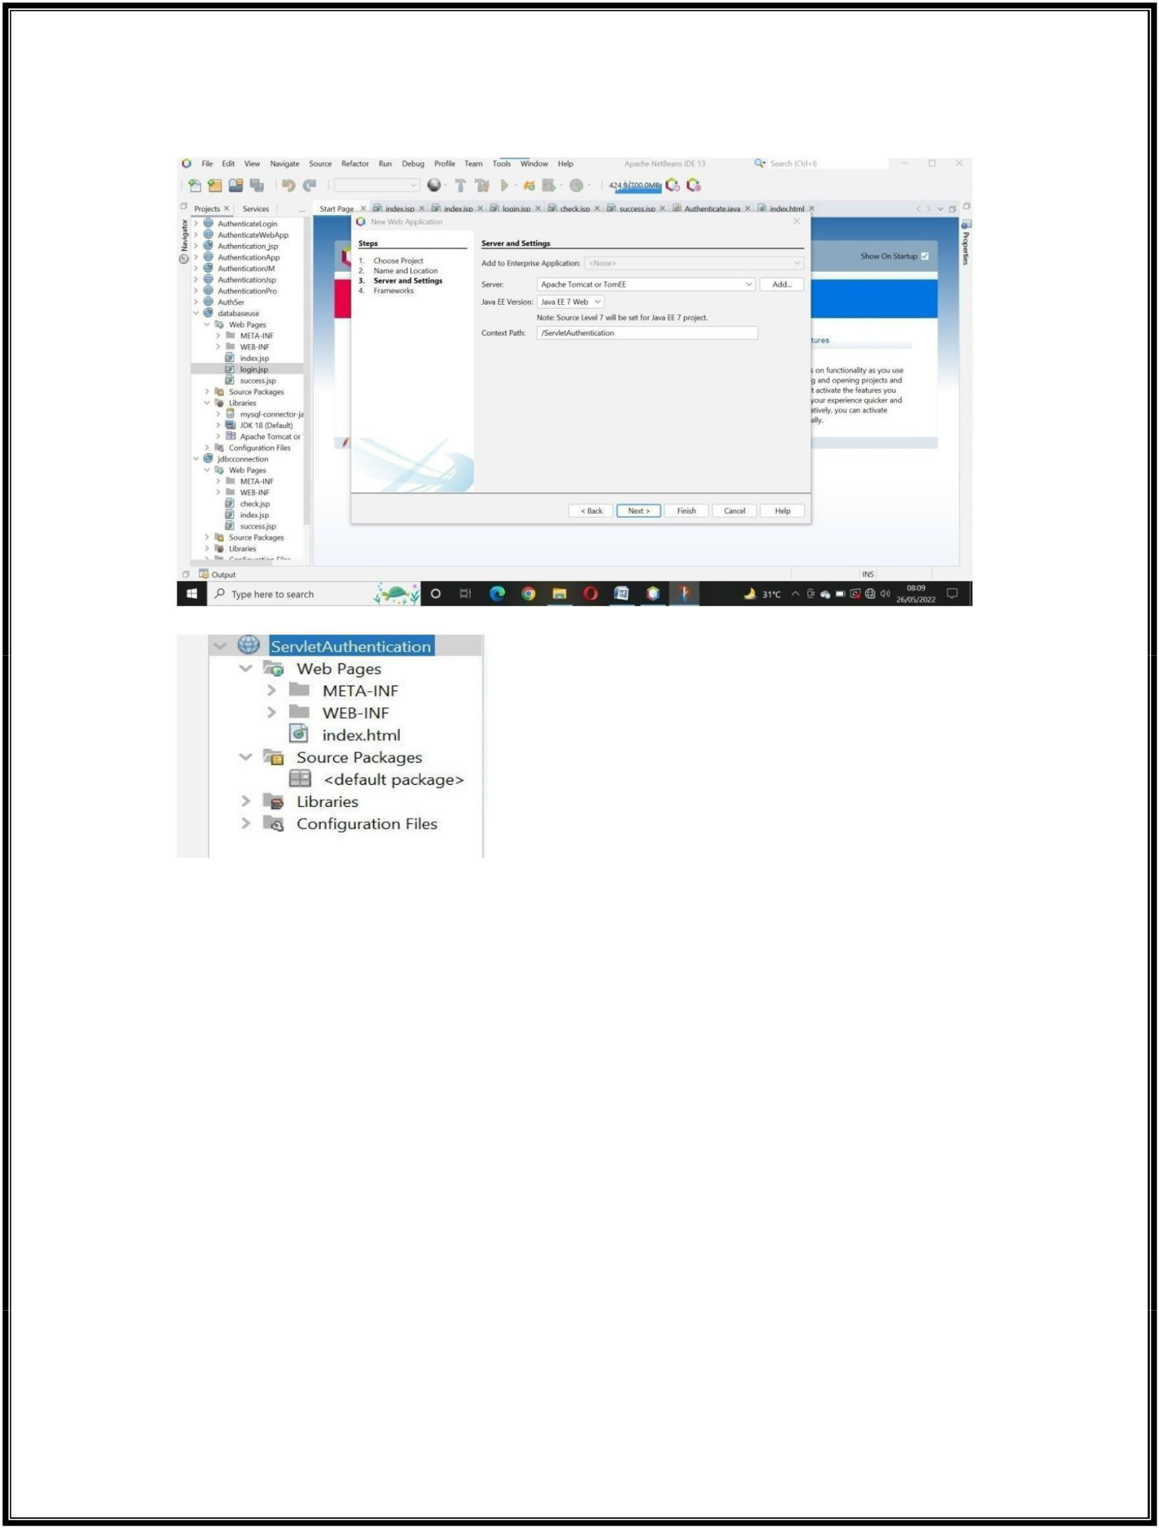

**Step 3:** Select the Server as ***Apache Tomcat or TomEE*** and Select Java EE Version as ***Java EE 7 Web*** -> click on ***Finish***

The Created Project visible at leftside of Netbeans IDE like below:

**Step 4:** implement the code for ***index.html***

<html>

<head>

<title>Authentication Using Servlet</title>

<meta charset="UTF-8">

<meta name="viewport" content="width=device-width, initial-scale=1.0"> </head>

<body>

<center>

<form method="POST" action="Auth"> <h1><u>Login Form</u></h1><!-- comment --> UserName: <input type="text" name="txtuname" /> <br/> Password: <input type="password" name="txtpassword" /> <br/> <input type="submit" value="Login"/>

</form>

</center>

</body>

</html>

22Q71A4454

**Web Application Development Lab - R20**

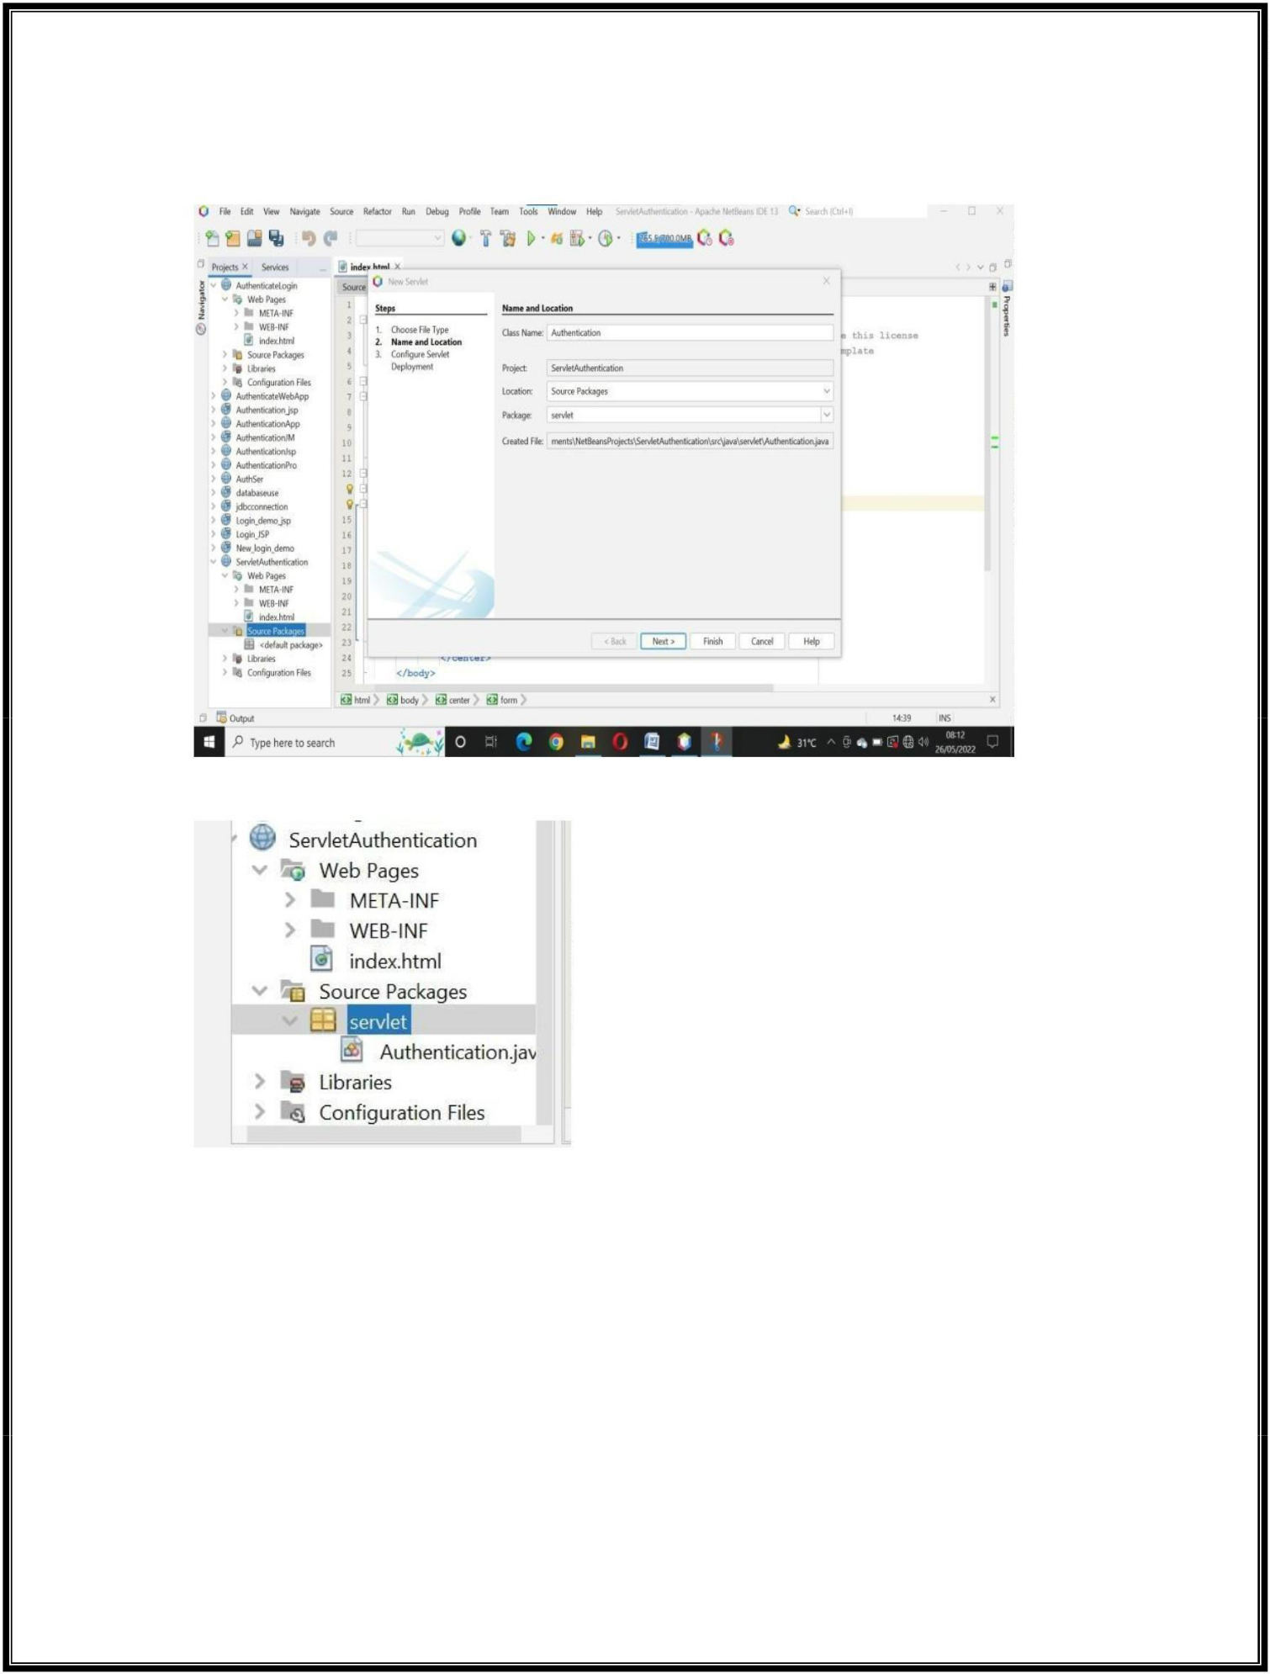

**Step 5:** Create a Servlet page: right click on ***Source Packages*** directory in your project -> enter the ***Class Name*** and fill the ***Package box*** with ***servlet*** -> click on ***Finish***

The Created servlet visible in the project at leftside of Netbeans IDE like below:

**Step 6:** implement the servlet code for ***dopost()*** method in ***Authentication.java***

protected void doPost(HttpServletRequest request, HttpServletResponse response) throws ServletException, IOException {

PrintWriter out=response.getWriter(); String u=request.getParameter("txtuname"); String p=request.getParameter("txtpassword"); if(u.equals("Dharma")&&p.equals("1234"))

response.sendRedirect("welcome.html");

else

out.println("<h1>Login Failed</h1>");

}

22Q71A4454

**Web Application Development Lab - R20**

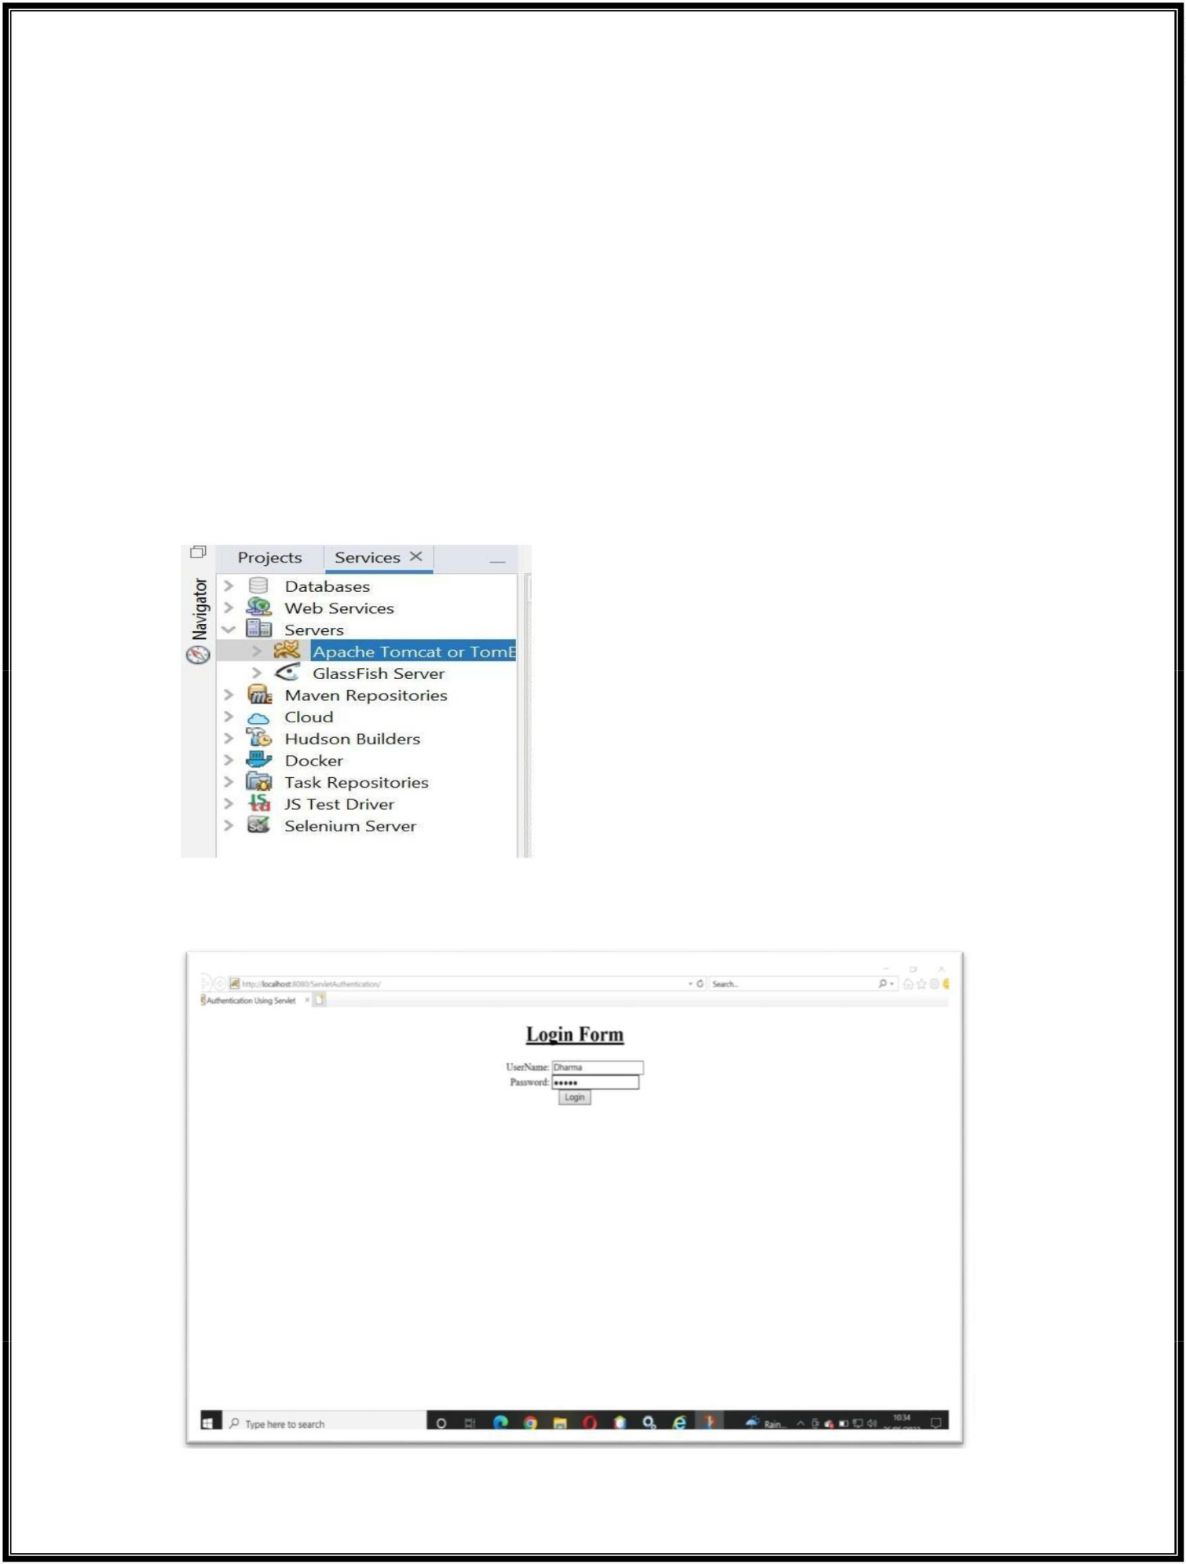

**Step 7:** Create ***welcome.html*** page: ***rignt click*** on project -> select ***Html*** -> enter the ***file name*** as ***welcome*** -> click on ***Finish***

<html>

<head>

<title>Welcome User</title>

<meta charset="UTF-8">

<meta name="viewport" content="width=device-width, initial-scale=1.0"> </head>

<body>

<center><h1>Welcome User...You Logged Success fully</h1></center> </body>

</html>

**Step 8:** Start the ***Tomcat Server***: go to ***Services*** -> open ***servers*** -> ***right click*** on Apache Tomcat or TomEE ->click on ***Start***

**Step 9:** To ***Run*** the Project: ***right click*** on Project -> click on ***Run***, then the output screen like below:

22Q71A4454

**Web Application Development Lab - R20**

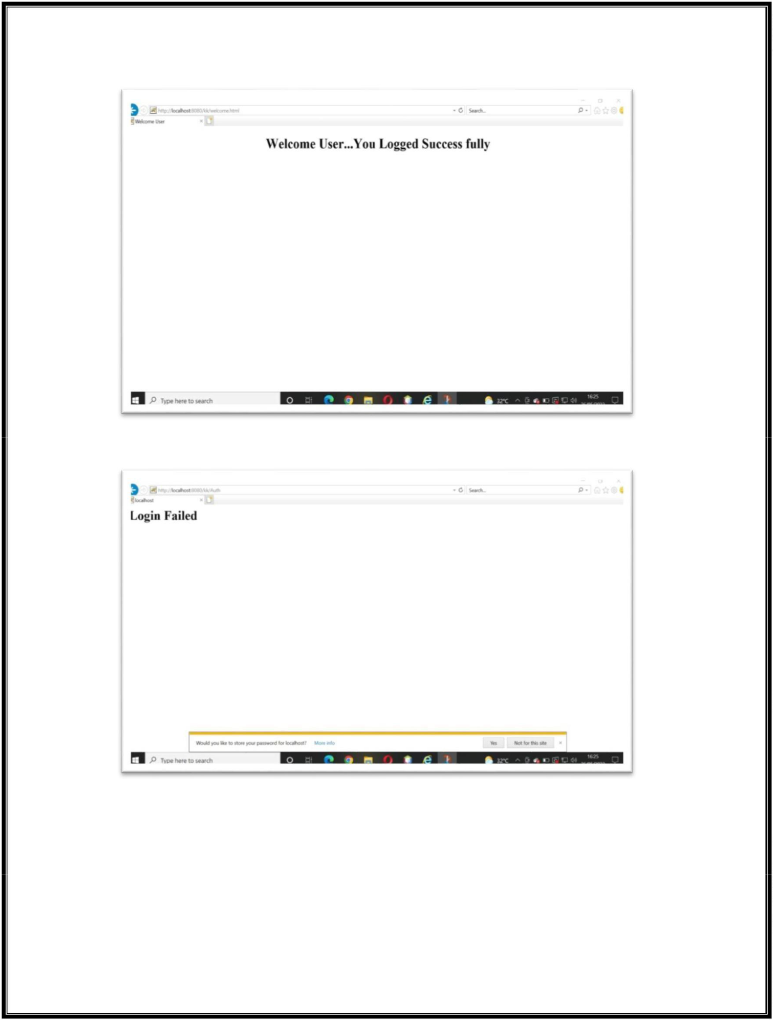

After click on ***Login*** button if the ***Authentication Successfull***, then the output like below:

After click on ***Login*** button if the ***Authentication not Successfull***, then the output like below:

22Q71A4454

**Web Application Development Lab - R20**



**Experiment – 2**

**Aim: Authentication Using JSP**

**Solution:** Follow the ***steps*** what we have done for ***Experiment -1*** to create a ***project***.

***Note:*** Here no need to create the ***servlet***. Using ***JSP*** pages we can implement this Experiment.

**Step 1:** Create below ***jsp pages***: ***right click*** on project -> select ***jsp*** -> Enter the ***File Name*** -> click on ***Finish***.

1. **login.jsp**

<html>

<head>

<meta http-equiv="Content-Type" content="text/html; charset=UTF-8"> <title>Authentication: JSP</title>

</head>

<body>

<center>

<h1>User Login</h1>

<form method="POST" action="http://localhost:8080/Login_JSP/auth.jsp"> Username:<input type="text" name="v1" value="" /><br/><br/> Password:<input type="password" name="v2" value="" /><br/><br/> <input type="submit" value="SUBMIT" />

</form>

</center>

</body>

</html>

1. **auth.jsp**

<html>

<head>

<meta http-equiv="Content-Type" content="text/html; charset=UTF-8"> <title>Authentication: JSP</title>

</head>

<body>

<%

String s=request.getParameter("v1");

String p=request.getParameter("v2");

if(s.equals("Dharma")&&p.equals("12345"))

response.sendRedirect("positive.html");

else

response.sendRedirect("negitive.html");

%>

</body>

</html>

22Q71A4454

**Web Application Development Lab - R20**



**Step 2:** Create below ***html pages***: ***right click*** on project -> select ***html*** -> Enter the ***File Name*** -> click on ***Finish.***

1. **positive.html**

<html>

<head>

<title>Authentication: JSP</title>

<meta charset="UTF-8">

<meta name="viewport" content="width=device-width, initial-scale=1.0"> </head>

<body>

<center>

<div><h1>Positive Response</h1><br/><!-- comment --> <h2>Welcome to the WORLD!</h2>

</div>

</center>

</body>

</html>

1. **negative.html**

<html>

<head>

<title>Authentication: JSP</title>

<meta charset="UTF-8">

<meta name="viewport" content="width=device-width, initial-scale=1.0">

</head>

<body>

<center>

<div><h1>Negative Authentication</h1><br/>

<h2> Sorry... You are Failed!</h2>

</div>

</center>

</body>

</html>

22Q71A4454

**Web Application Development Lab - R20**

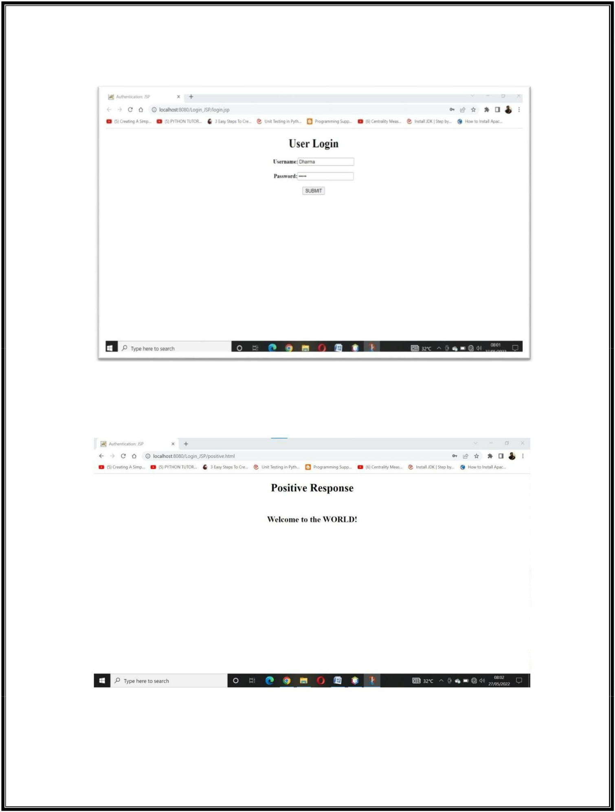

**Step 3:** Run the ***project***: ***right clic***k on project -> click on ***Run***, then the output screen like below:

After click on ***SUBMIT*** button if the ***Authentication Successfull***, then the output like below:

22Q71A4454

**Web Application Development Lab - R20**

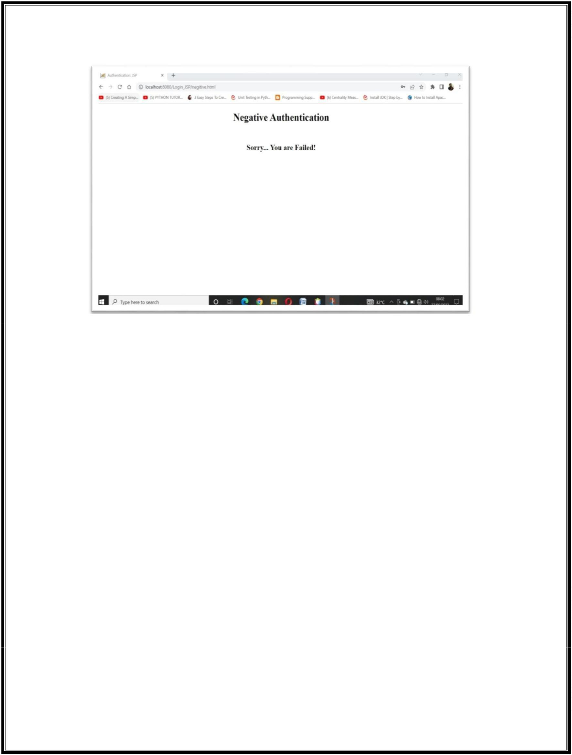

After click on ***SUBMIT*** button if the ***Authentication not Successfull***, then the output like below:

22Q71A4454

**Web Application Development Lab - R20**

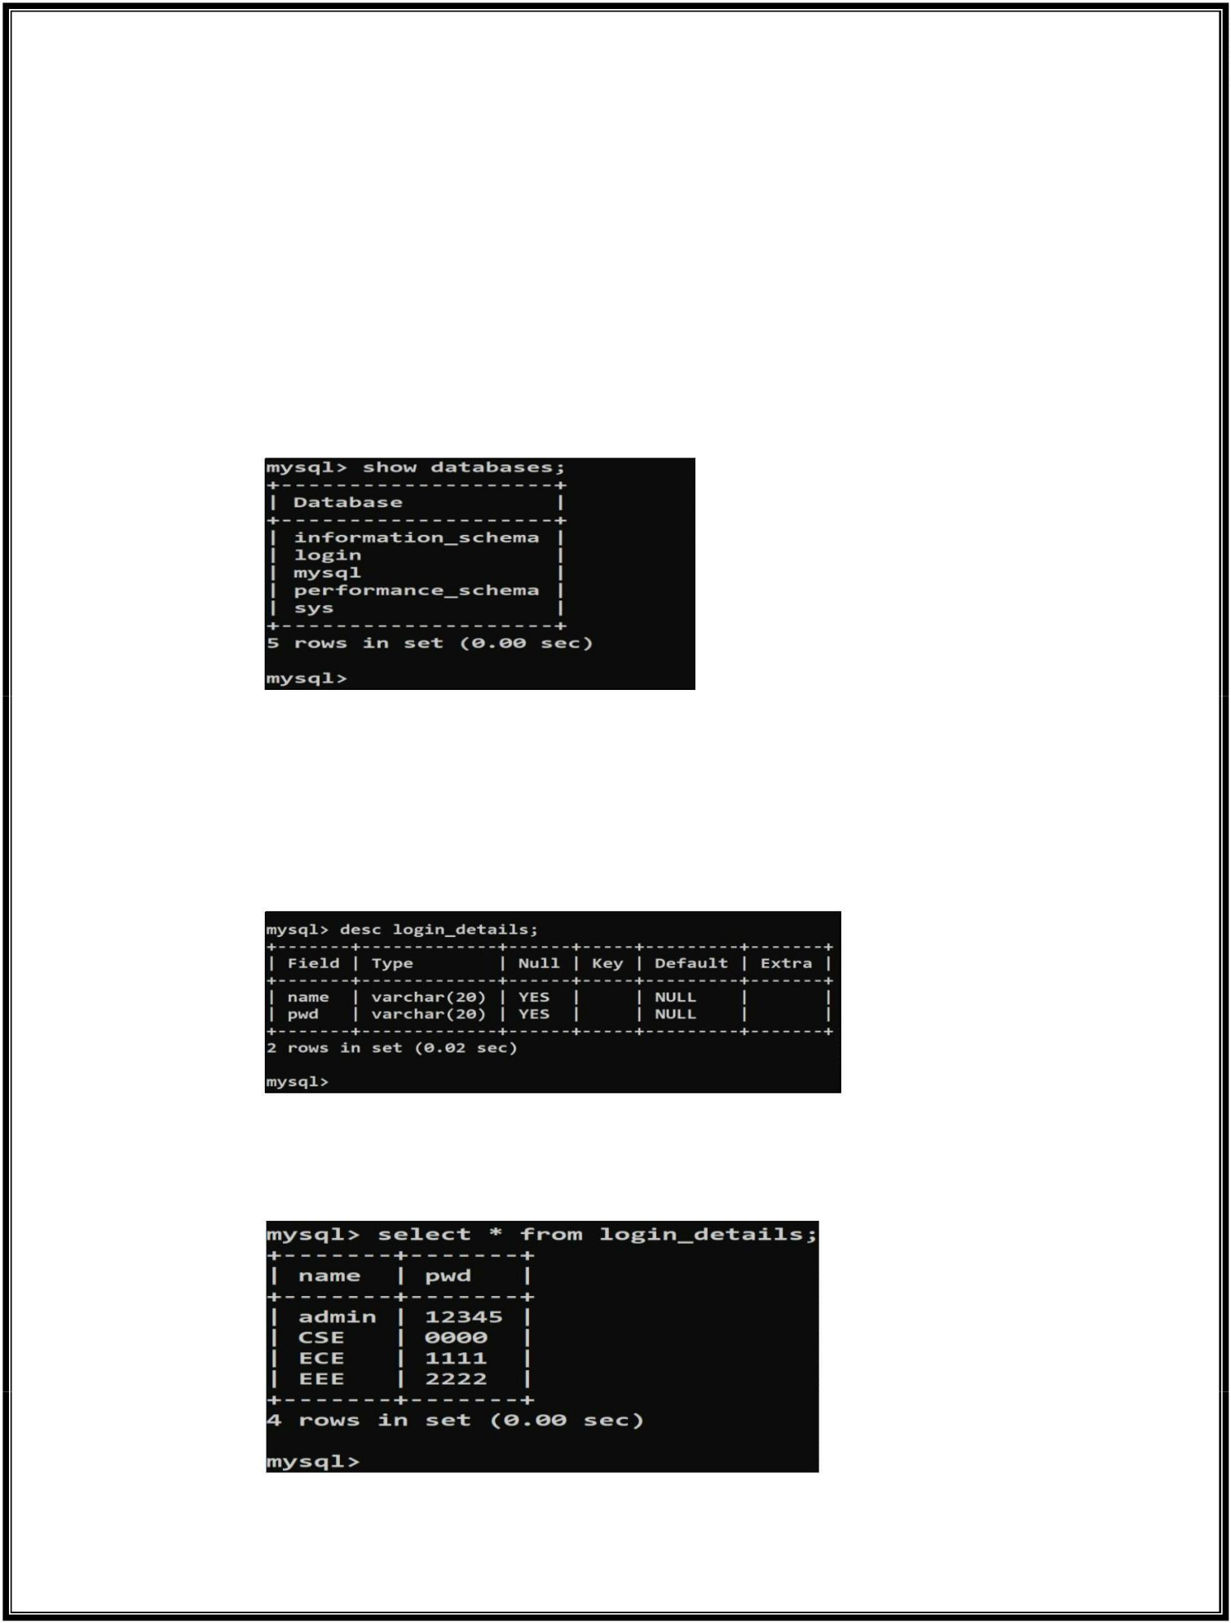

**Experiment – 3**

**Aim:** Connect MySql using JSP.

**Solution:**

**Step 1:**

Create a database with name ***login*** in MySQL, using below commands:



**mysql>** create database login;

check the database whether created or not:



use the created database to create a table:



**mysql>** use login;

Database changed

Now, Create the table ***login_details*** with 2 fields i.e, ***name,password***:



**mysql>** create table login_details(name varchar(20),password varchar(20)); Query OK, 0 rows affected (0.12 sec)

Check the table created or not:



Insert data into the table using the query ***insert*** like below:



**mysql>** insert into login_details(name,password) values('admin','12345'); Query OK, 1 row affected (0.04 sec)

After inserting 4rows the resultant table like below:



22Q71A4454

**Web Application Development Lab - R20**



Follow the ***steps*** what we have done for ***Experiment -1*** to create a ***project***. ***Note:*** Here no need to create the ***servlet***. Using ***JSP*** pages we can implement this Experiment.

**Step 2:** Create below ***jsp pages***: ***right click*** on project -> select ***jsp*** -> Enter the ***File Name*** -> click on ***Finish***.

***index.jsp:***

<html>

<head>

<meta http-equiv="Content-Type" content="text/html; charset=UTF-8"> <title>JSP with MySQL</title>

</head>

<body>

<center>

<h1>User Login</h1>

<form method="POST" action="http://localhost:8080/databaseuse/login.jsp"> Username:<input type="text" name="v1" value="" /><br/> Password:<input type="password" name="v2" value="" /><br/>

<input type="submit" value="SUBMIT" />

</form>

</center>

</body>

</html>

***login.jsp:***

<%@page import="java.sql.*"%>

<%@page contentType="text/html" pageEncoding="UTF-8"%> <!DOCTYPE html>

<html>

<head>

<meta http-equiv="Content-Type" content="text/html; charset=UTF-8"> <title>JSP with MySQL</title>

</head>

<body>

<%

String name=request.getParameter("v1");

String pwd=request.getParameter("v2");

try{

Class.forName("com.mysql.jdbc.Driver");

Connection

con=DriverManager.getConnection("jdbc:mysql://localhost:3306/login","root","12345"); Statement s=con.createStatement();

ResultSet r=s.executeQuery("select * from login_details where name='"+name+"' and pwd='"+pwd+"'");

if(r.next()){

response.sendRedirect("success.jsp");

22Q71A4454

**Web Application Development Lab - R20**

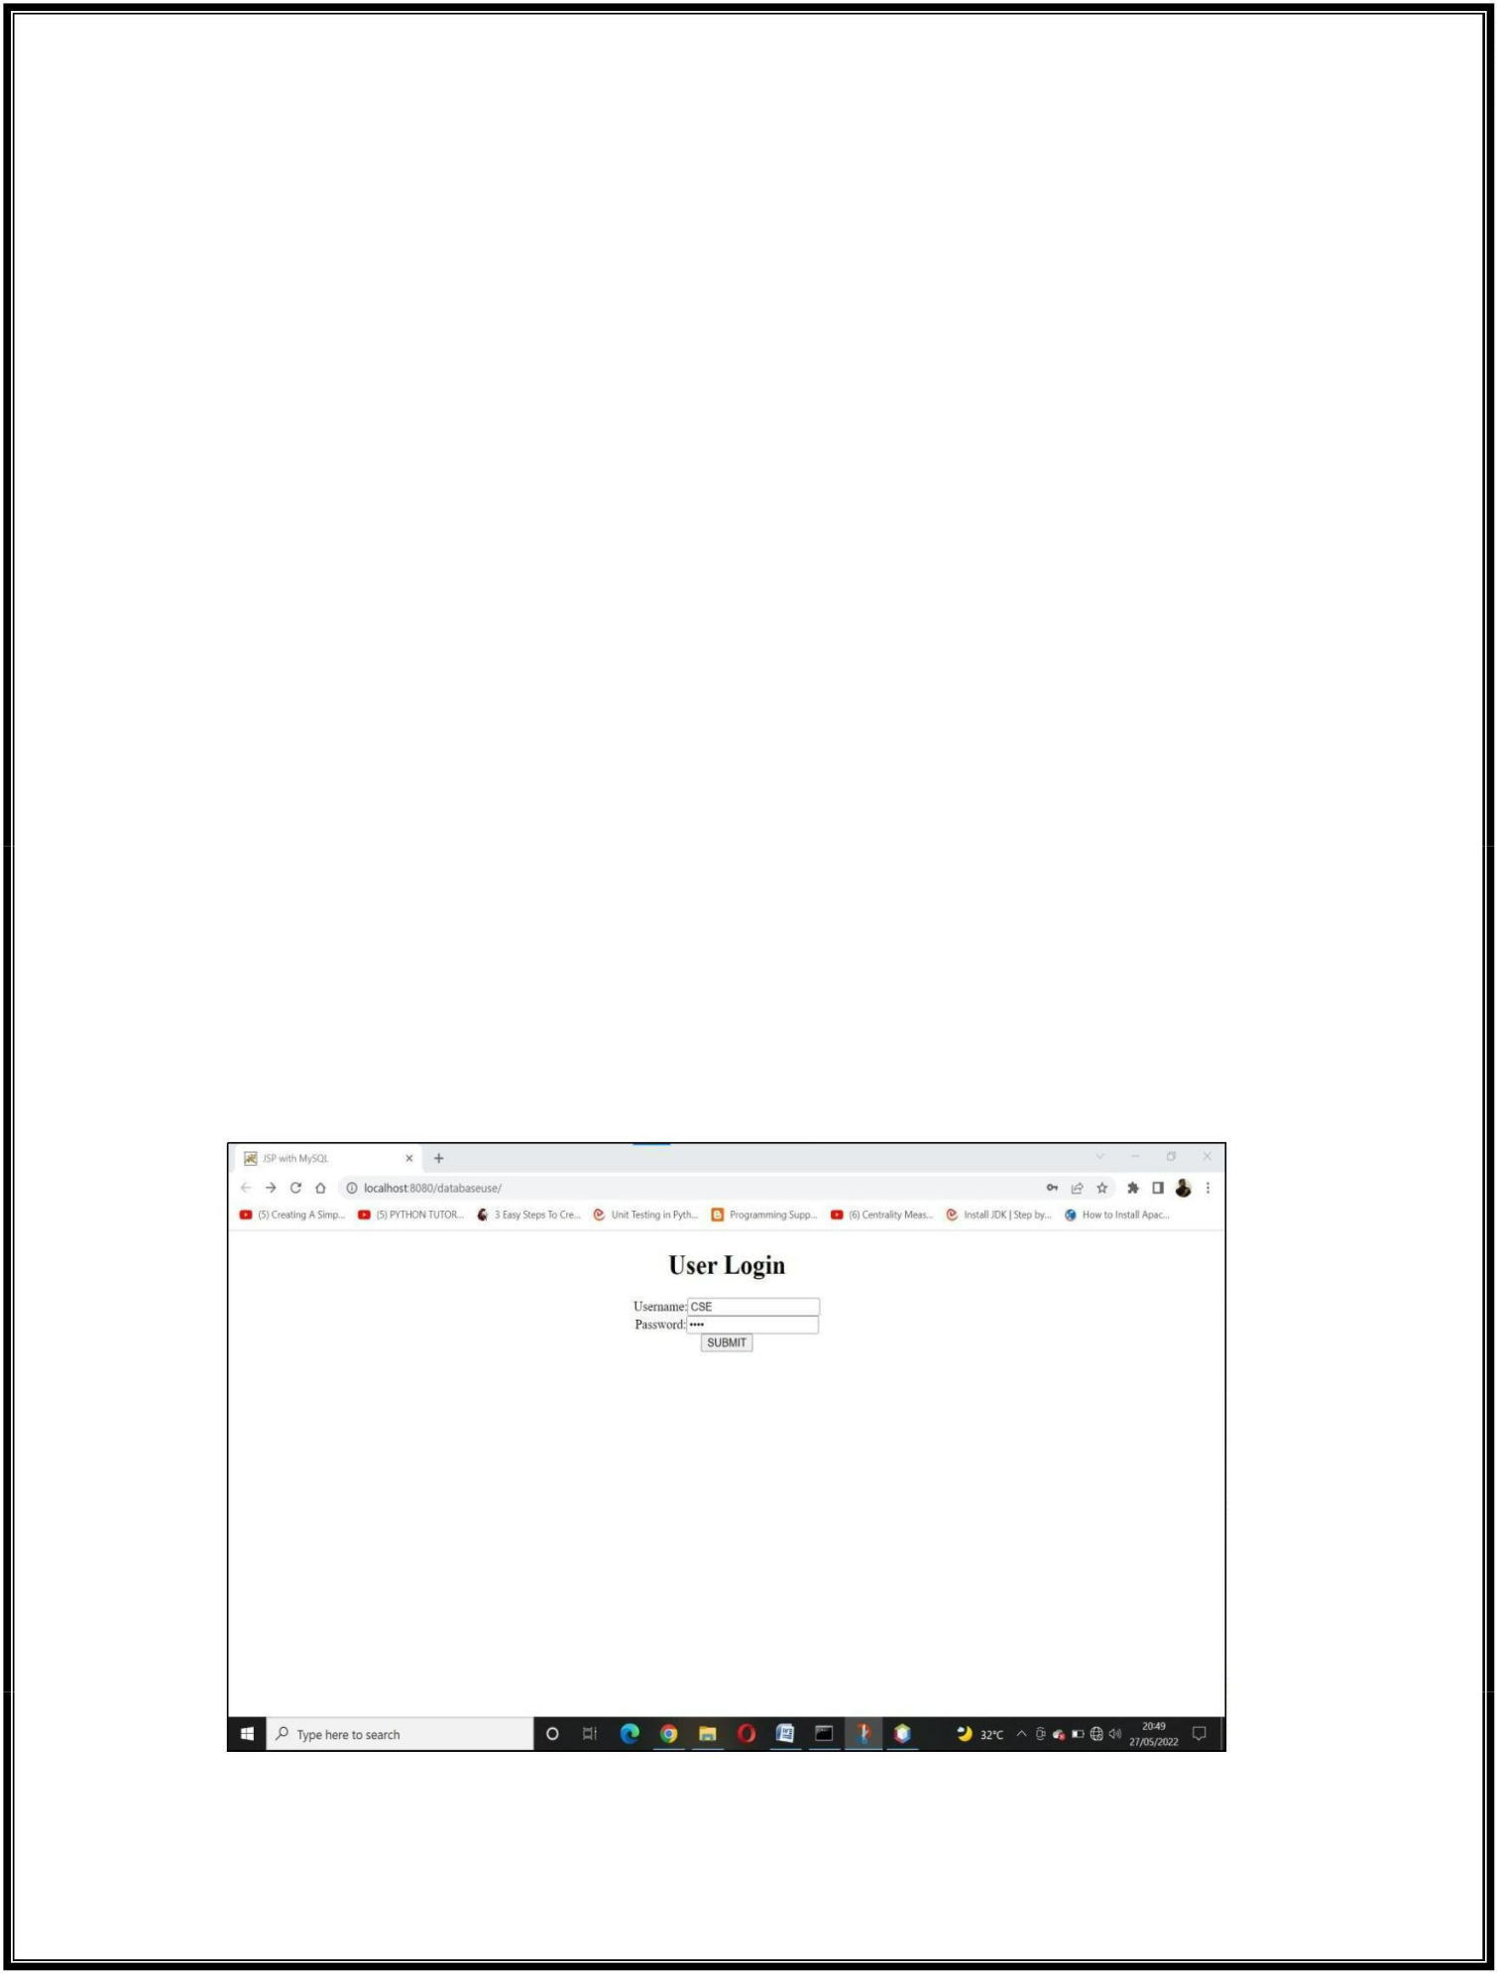

}

else

{

out.println("<h1>name and password not matched</h1>");

}

}

catch(Exception e){

}

%>

</body>

</html>

**success.jsp:**

<html>

<head>

<meta http-equiv="Content-Type" content="text/html; charset=UTF-8"> <title>JSP with MySQL</title>

</head>

<body>

<h1>Successfully Logged......!</h1>

<h1>Welcome to MYSQL Login...!</h1>

</body>

</html>

**Step 3:** Run the ***project***: ***right clic***k on project -> click on ***Run***, then the output screen like below:

22Q71A4454

**Web Application Development Lab - R20**

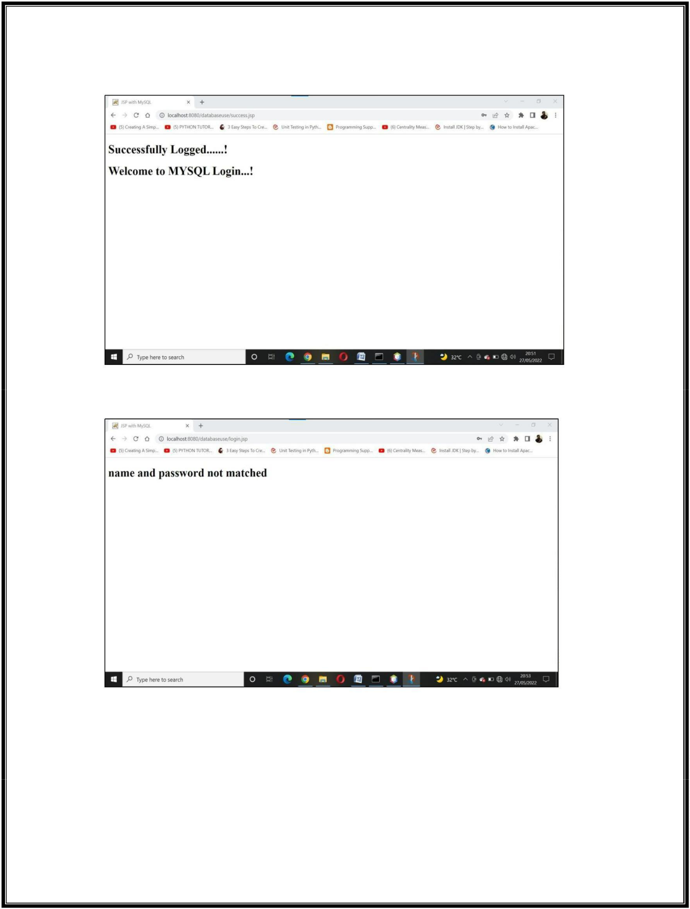

After click on ***SUBMIT*** button if the ***Authentication Successfull***, then the output like below:

After click on ***SUBMIT*** button if the ***Authentication not Successfull***, then the output like below:

22Q71A4454

**Web Application Development Lab - R20**



22Q71A4454